Gicumbi District

Kageyo Sector

Kageyo TSS

L4 Software Development

Data Structure and Algorithm Fundamentals

SWDDA401

Academic Year:

2025-2026

Students Notes

Prepared by:

Joseph Marie ASHIMIRWE

On: 11th Sept 2025

At Kageyo TSS



MODULE CODE AND TITLE: SWDDA401 DATA STRUCTURE AND ALGORITHM FUNDAMENTALS

Learning Outcome 1: Apply algorithm Fundamentals

Learning Outcome 2: Apply Data Structure.

Learning Outcome 3: Implement Algorithm using JavaScript.

**Learning Outcome 1: Apply Algorithm Fundamentals**

**Indicative content 1.1: Conversion of Number Systems**

A **number system** is a structured way of representing numbers using a set of symbols (digits) and rules for combining them. It defines how numbers are expressed and manipulated based on a specific base (or radix), which determines the number of unique digits used and the value of each position in a number.

**Common Number Systems:**

**Decimal**: Used in everyday arithmetic.

**Binary**: Used in computers for data representation.

**Octal**: Used in some computing applications (e.g., UNIX permissions).

**Hexadecimal**: Used for compact binary representation (e.g., memory addresses).

**Unary**: Represents numbers by repeating a single symbol (e.g., 5 = 11111), used in theoretical models.

**1. Description of Key Concepts (Bases)**

A number system's **base** (or **radix**) defines how many digits are available, including zero. The rightmost digit is the least significant digit (LSD), and the leftmost is the most significant digit (MSD).

|  |  |  |  |
| --- | --- | --- | --- |
| Base (Radix) | Name | Digits Available | Primary Use Case |
| **10** | Decimal | 0, 1, 2, 3, 4, 5, 6, 7, 8, 9 | Human representation. The default system. |
| **2** | Binary | 0, 1 | The fundamental language of computers. All data is stored as bits. |
| **8** | Octal | 0, 1, 2, 3, 4, 5, 6, 7 | A more compact representation of binary (historically significant). |
| **16** | Hexadecimal | 0, 1, 2, 3, 4, 5, 6, 7, 8, 9, A, B, C, D, E, F | The most common compact representation of binary (e.g., memory addresses, colors). |
| **1** | Unary | 1 (or sometimes 0) | Tally marking. Not a positional system. The value is the number of marks (e.g., 111 = 3). |

**2. Conversion from Decimal Base**

The general method is to repeatedly divide by the target base and note the remainders (reading them from bottom to top).

**a) Decimal to Binary (and vice versa)**

* **Conversion (Decimal → Binary):**
  1. Divide the decimal number by 2.
  2. Write down the remainder (this will be either 0 or 1).
  3. Divide the quotient from step 1 by 2 again.
  4. Repeat steps 2-3 until the quotient is 0.
  5. The binary number is the remainders read from bottom to top.

**Example: Convert 29₁₀ to Binary.**

29 / 2 = 14, remainder 1 ↑ (MSB: Most Significant Bit)

14 / 2 = 7, remainder 0 │

7 / 2 = 3, remainder 1 │ Read

3 / 2 = 1, remainder 1 │ Remainders

1 / 2 = 0, remainder 1 ↓ (LSB: Least Significant Bit)

**Result: 29₁₀ = 11101₂**

* **Conversion (Binary → Decimal):**Use the Positional Notation (Expand & Add) method. Multiply each bit by 2^(position) (starting from 0 on the right) and sum the results.

**Example:** Convert 10110₂ to Decimal.

1 0 1 1 0₂

↓ ↓ ↓ ↓ ↓

1*2⁴ + 0*2³ + 1*2² + 1*2¹ + 0*2⁰

= 16 + 0 + 4 + 2 + 0

= 22₁₀

**Result: 10110₂ = 22₁₀**

**b) Decimal to Octal (and vice versa)**

* **Conversion (Decimal → Octal):**Same as Decimal to Binary, but divide by 8.

**Example:** Convert 125₁₀ to Octal.

125 / 8 = 15, remainder 5 ↑

15 / 8 = 1, remainder 7 │ Read

1 / 8 = 0, remainder 1 ↓

**Result:** 125₁₀ = 175₈

* **Conversion (Octal → Decimal):**  
  Use the Positional Notation method with a base of 8.

**Example: Convert**345₈**to Decimal.**

3 4 5₈

↓ ↓ ↓

3*8² + 4*8¹ + 5*8⁰

= 192 + 32 + 5

= 229₁₀

**Result:** 345₈ = 229₁₀

**c) Decimal to Hexadecimal (and vice versa)**

* **Conversion (Decimal → Hexadecimal):**  
  Same as before, but divide by **16**. Remember remainders 10-15 become A-F.

**Example: Convert**255₁₀**to Hexadecimal.**

255 / 16 = 15, remainder 15 (F) ↑

15 / 16 = 0, remainder 15 (F) ↓

**Result:** 255₁₀ = FF₁₆

* **Conversion (Hexadecimal → Decimal):**  
  Use the **Positional Notation** method with a base of 16. Convert letters A-F to 10-15.

**Example: Convert**1A3₁₆**to Decimal.**

1 A 3₁₆ (A = 10)

↓ ↓ ↓

1*16² + 10*16¹ + 3*16⁰

= 256 + 160 + 3

= 419₁₀

**Result:** 1A3₁₆ = 419₁₀

**3. Conversion from Hexadecimal Base**

Hexadecimal is excellent because it maps perfectly to binary (1 hex digit = 4 binary digits).

**a) Hexadecimal to Binary (and vice versa)**

* **Conversion (Hex → Binary):**  
  Convert **each hexadecimal digit** to its **4-bit binary equivalent**.

**Example: Convert**B2F₁₆**to Binary.**

B₁₆ = 11₁₀ = 1011₂

2₁₆ = 2₁₀ = 0010₂

F₁₆ = 15₁₀ = 1111₂

**Result:** B2F₁₆ = 1011 0010 1111₂ (Spaces for clarity)

* **Conversion (Binary → Hex):**

1. Group the binary number into sets of **4 bits**, starting from the right. Pad with leading zeros if needed.
2. Convert each 4-bit group to its hexadecimal equivalent.

Example: Convert 1101011011₂ to Hex.

Group: 11 0101 1011 → (Pad left) → 0011 0101 1011

0011₂ = 3₁₆

0101₂ = 5₁₆

1011₂ = B₁₆

Result: 1101011011₂ = 35B₁₆

**b) Hexadecimal to Octal (and vice versa)**

The easiest way is to use binary as an intermediary.

* **Hex → Octal:**
  1. Convert Hex → Binary (1 digit to 4 bits).
  2. Convert Binary → Octal (group the new binary string into sets of 3 bits, starting from the right, and convert).

**Example: Convert A7₁₆ to Octal.**

* 1. A₁₆ = 1010₂, 7₁₆ = 0111₂ → 10100111₂
  2. Group 10100111₂ into 3s: 010 100 111 (pad a leading zero)
  3. 010₂=2₈, 100₂=4₈, 111₂=7₈  
     **Result: A7₁₆ = 247₈**
* **Octal → Hex:**
  1. Convert Octal → Binary (1 digit to 3 bits).
  2. Convert Binary → Hex (group the new binary string into sets of 4 bits, starting from the right, and convert).

**c) Hexadecimal to Decimal (and vice versa)**

This is covered in sections 2c and 3c above.

**4. Conversion from Octal Base**

Octal also maps perfectly to binary (1 octal digit = 3 binary digits).

**a) Octal to Binary (and vice versa)**

* **Conversion (Octal → Binary):**Convert each octal digit to its 3-bit binary equivalent.

**Example:** Convert 75₈ to Binary.

7₈ = 111₂

5₈ = 101₂

**Result: 75₈ = 111101₂**

* **Conversion (Binary → Octal):**
  1. Group the binary number into sets of 3 bits, starting from the right. Pad with leading zeros if needed.
  2. Convert each 3-bit group to its octal equivalent.

Example: Convert 101110₂ to Octal.

Group: 101 110

101₂ = 5₈

110₂ = 6₈

**Result: 101110₂ = 56₈**

**b) Octal to Decimal (and vice versa)**

This is covered in section 2b above.

**c) Octal to Hexadecimal (and vice versa)**

This is covered in section 3b above, using binary as the intermediary.

**5. Applications in Data Structures and Algorithms**

* **Memory Addressing:** Hexadecimal is used for memory addresses due to its compactness (e.g., 0x1A3 vs. 110100011 in binary).
* **Bitwise Operations:** Binary is essential for operations like AND, OR, XOR in algorithms (e.g., checking if a number is even: num & 1 == 0).
* **File Permissions:** Octal is used in UNIX systems (e.g., 755 = read/write/execute permissions).
* **Cryptography:** Number base conversions are used in encoding/decoding algorithms.
* **Hashing:** Hexadecimal is used to represent hash values (e.g., SHA-256 outputs in hex).
* Many network packets and hardware identifiers (like MAC addresses) are represented in Hex (00:1A:2B:3C:4D:5E).
* **Color Codes (Web Development):** Ex: Colors in HTML/CSS are defined by their RGB components in Hexadecimal (e.g., #FF5733). #FF represents the Red component (255₁₀), 57 Green, 33 Blue.

**Summary Table of Conversions**

|  |  |  |  |  |
| --- | --- | --- | --- | --- |
| From \ To | Decimal | Binary | Octal | Hexadecimal |
| Decimal | - | Divide by 2, read remainders | Divide by 8, read remainders | Divide by 16, read remainders |
| Binary | Sum powers of 2 | - | Group by 3, convert to 0–7 | Group by 4, convert to 0–F |
| Octal | Sum powers of 8 | Each digit to 3 bits | - | Octal → Binary → Hex |
| Hexadecimal | Sum powers of 16 | Each digit to 4 bits | Hex → Binary → Octal | - |

**6. Application for Number base Arithmetic Operations**

The rules for addition, subtraction, multiplication, and division are the same in every number system. The only thing that changes is the base, which determines:

1. The number of unique digits available.
2. The point at which you carry (in addition/multiplication) or borrow (in subtraction).

The process feels identical to the decimal arithmetic you already know.

**1. Binary Arithmetic (Base 2)**

Why it's used: It's the native language of computers. All arithmetic operations at the hardware level (in the CPU) are performed in binary using logic gates.

a) Binary Addition

Rule: 0 + 0 = 0, 1 + 0 = 1, 1 + 1 = 10 (write 0, carry 1), 1 + 1 + 1 = 11 (write 1, carry 1).

Example: Add 1011₂ (11₁₀) and 1101₂ (13₁₀)

Carry: 1 1 1 1

1 0 1 1

+ 1 1 0 1

---------

1 1 0 0 0 (Binary)

Check: 11 + 13 = 24, and 11000₂ = 16 + 8 = 24₁₀

**b) Binary Subtraction**

Rule: 0 - 0 = 0, 1 - 0 = 1, 1 - 1 = 0, 0 - 1 = 1 (after borrowing 1, making it 10 - 1 = 1).

Example: Subtract 1100₂ (12₁₀) from 11011₂ (27₁₀)

Borrow: 1 0 1 1 (Explanation: Borrow from the next '1' to the left)

1 1 0 1 1

- 1 1 0 0

-----------

1 1 1 1 (Binary)

Check: 27 - 12 = 15, and 1111₂ = 8+4+2+1 = 15₁₀

**2. Octal Arithmetic (Base 8)**

Why it's used: It was a convenient shorthand for binary (3 bits = 1 octal digit) in older computer systems.

**a) Octal Addition**

Rule: Add column by column. If the sum is 8 or more, subtract 8 and carry 1 to the next column.

Example: Add 47₈ (39₁₀) and 35₈ (29₁₀)

Carry: 1

4 7

+ 3 5

-----

1 0 4 (Octal)

**b) Octal Subtraction**

**Rule:** Subtract column by column. If the top digit is smaller, borrow 1 from the left (which represents 8 in the current column).

**Example: Subtract**25₈ (21₁₀)**from**63₈ (51₁₀)

Borrow: 1 (Borrow 1, making the 3 become 8+3=11)

6 3

- 2 5

-----

3 6 (Octal)

Check: 51 - 21 = 30. 36₈ = (3*8) + (6*1) = 24+6=30₁₀

**3. Decimal Arithmetic (Base 10)**

**Why it's used:** It's the human default system, used in everyday life, commerce, science, and engineering.

You already know this! Every math problem you've ever done uses decimal arithmetic. The rules for carrying and borrowing are defined by base 10.

**Example: Add 168 and 295**

Carry: 1 1

1 6 8

+ 2 9 5

-------

4 6 3 (Decimal)

**4. Hexadecimal Arithmetic (Base 16)**

**Why it's used:** It's the modern shorthand for binary (4 bits = 1 hex digit), used for memory addresses, machine code, and color codes.

**a) Hexadecimal Addition**

**Rule:** Add column by column. If the sum is 16 or more, subtract 16 and carry 1 to the next column. Remember A=10, B=11, C=12, D=13, E=14, F=15.

**Example: Add**A7₁₆ (167₁₀)**and**B5₁₆ (181₁₀)

**Indicative content 1.2: Description of Logic Gates and Expressions**

**1. Logic Gates**

Logic gates are the fundamental building blocks of digital circuits, used in computers, microprocessors, and other electronic systems. They perform basic logical operations on binary inputs (0 or 1, representing false or true) to produce a single binary output. Each gate implements a specific Boolean function, which is a mathematical representation of logical relationships.

**Logic gates are essential for:**

* Performing computations in digital systems (e.g., CPUs, memory units).
* Implementing decision-making logic in circuits (e.g., adders, multiplexers).
* Enabling data processing, storage, and communication in electronics.

**Common Logic Gates**

The following are the standard logic gates, each with a specific logical operation:

**AND Gate:** Outputs 1 only if **all** inputs are 1; otherwise, outputs 0.

**OR Gate:** Outputs 1 if **at least one** input is 1; otherwise, outputs 0.

**NOT Gate:** Outputs the **inverse** of the input (0 becomes 1, 1 becomes 0).

**NAND Gate:** Outputs 0 only if **all** inputs are 1 (inverse of AND).

**NOR Gate:** Outputs 1 only if **all** inputs are 0 (inverse of OR).

**XOR Gate:** Outputs 1 if an **odd number** of inputs are 1 (exclusive OR).

**XNOR Gate:** Outputs 1 if **all inputs are the same** (even number of 1s, inverse of XOR).

**2. Types of Logic Gates**

Logic gates are categorized into three types based on their functionality and versatility:

* **Basic Gates:** AND, OR, and NOT gates**.** These are the simplest gates, forming the foundation for other gates and circuits.
* **Universal Gates:** NAND and NOR gates. These are called universal because any Boolean function or logic circuit can be implemented using only NAND or only NOR gates, making them highly versatile.
* **Derived Gates:** XOR and XNOR gates. These are specialized gates derived from combinations of basic gates, often used in specific applications like arithmetic circuits (e.g., half adders, full adders, subtractors).

**Universal Gates**

* NAND and NOR are universal because they can replicate the functionality of AND, OR, and NOT gates:
  + Example: An AND gate can be constructed using multiple NAND gates (e.g., NAND followed by NAND to invert the output).
  + Example: A NOT gate can be created by tying both inputs of a NAND or NOR gate together.
* This property makes NAND and NOR gates cost-effective and widely used in circuit design.

**Derived Gates**

* XOR and XNOR are derived from combinations of basic gates:
  + XOR: Used in circuits requiring exclusive conditions (e.g., in adders to compute sums).
  + XNOR: Used in circuits checking for equality (e.g., in comparators).
* These gates are not universal but are critical for specific applications like arithmetic and error detection.

3. Representation of Boolean Logic Gates

Each logic gate corresponds to a Boolean expression and can be represented using a truth table, which lists all possible input combinations and their corresponding outputs. Below, I’ll describe each gate, its Boolean expression, truth table, and provide examples to illustrate their operation.

|  |  |  |  |  |  |
| --- | --- | --- | --- | --- | --- |
| Logic  gate | Illustration | Function | Truth table | | |
| Transfer |  | A | A | | Out |
| 0 | | 0 |
| 1 | | 1 |
|  | | |
| NOT |  |  | A | | Out |
| 1 | | 0 |
| 0 | | 1 |
| AND |  | A .B | A | B | Out |
| 0 | 0 | 0 |
| 0 | 1 | 0 |
| 1 | 0 | 0 |
| 1 | 1 | 1 |
| NAND |  |  | A | B | Out |
| 0 | 0 | 1 |
| 0 | 1 | 1 |
|  |  |  | 1 | 0 | 1 |
| 1 | 1 | 0 |
| OR |  | A + B | A | B | Out |
| 0 | 0 | 0 |
| 0 | 1 | 1 |
| 1 | 1 | 1 |
| 1 | 1 | 1 |
| NOR |  |  | A | B | Out |
| 0 | 0 | 1 |
| 0 | 1 | 0 |
| 1 | 0 | 0 |
| 1 | 1 | 0 |
| XOR |  |  | A | B | Out |
| 0 | 0 | 0 |
| 0 | 1 | 1 |
| 1 | 0 | 1 |
| 1 | 1 | 0 |
| XNOR |  |  | A | B | Out |
| 0 | 0 | 1 |
| 0 | 1 | 0 |
| 1 | 0 | 0 |
|  |  |  | 1 | 1 | 1 |

**Representation of Boolean Logic Gates**

**1. AND Gate**

* Description: Outputs 1 only if all inputs are 1; otherwise, outputs 0.
* Boolean Expression: For inputs A and B, the output is Y=A⋅B (logical AND).
* Truth Table:

| A | B | Y (A · B) |
| --- | --- | --- |
| 0 | 0 | 0 |
| 0 | 1 | 0 |
| 1 | 0 | 0 |
| 1 | 1 | 1 |

* Example:
  + Scenario: A circuit controls a light that turns on only if both switches (A and B) are on.
  + Inputs: A = 1 (switch 1 on), B = 1 (switch 2 on) → Output: Y = 1 (light on).
  + Inputs: A = 1, B = 0 → Output: Y = 0 (light off).

**2. OR Gate**

* Description: Outputs 1 if at least one input is 1; otherwise, outputs 0.
* Boolean Expression: Y=A+B (logical OR).
* Truth Table:

| A | B | Y (A + B) |
| --- | --- | --- |
| 0 | 0 | 0 |
| 0 | 1 | 1 |
| 1 | 0 | 1 |
| 1 | 1 | 1 |

* Example:
  + Scenario: A security system triggers an alarm if either sensor A or sensor B detects motion.
  + Inputs: A = 0 (no motion), B = 1 (motion detected) → Output: Y = 1 (alarm triggered).
  + Inputs: A = 0, B = 0 → Output: Y = 0 (no alarm).

**3. NOT Gate**

* Description: Outputs the inverse of the input (single input gate).
* Boolean Expression: Y=A‾ (logical NOT).
* Truth Table:

| A | Y (¬A) |
| --- | --- |
| 0 | 1 |
| 1 | 0 |

* Example:
  + Scenario: A circuit inverts a signal to control a device (e.g., a button press turns off a device).
  + Input: A = 1 (button pressed) → Output: Y = 0 (device off).
  + Input: A = 0 (button not pressed) → Output: Y = 1 (device on).

**4. NAND Gate (Universal Gate)**

* Description: Outputs 0 only if all inputs are 1 (inverse of AND).
* Boolean Expression: 
* Truth Table:

| A | B | Y (¬(A · B)) |
| --- | --- | --- |
| 0 | 0 | 1 |
| 0 | 1 | 1 |
| 1 | 0 | 1 |
| 1 | 1 | 0 |

* Example:
  + Scenario: A system disables an output if both inputs are active (e.g., a safety lock).
  + Inputs: A = 1, B = 1 → Output: Y = 0 (lock engaged).
  + Inputs: A = 0, B = 1 → Output: Y = 1 (lock disengaged).
* **Universal Property:** A NAND gate can create:
  + NOT: Tie inputs together (NAND(A,A) = ¬(A·A) = ¬A).
  + AND: NAND followed by NOT (using another NAND).
  + OR: Use NAND gates to combine inverted inputs.

**5. NOR Gate (Universal Gate)**

* Description: Outputs 1 only if all inputs are 0 (inverse of OR).
* Boolean Expression: 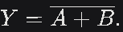
* Truth Table:

| A | B | Y (¬(A + B)) |
| --- | --- | --- |
| 0 | 0 | 1 |
| 0 | 1 | 0 |
| 1 | 0 | 0 |
| 1 | 1 | 0 |

* Example:
  + Scenario: A circuit outputs a signal only if no inputs are active (e.g., a power-off indicator).
  + Inputs: A = 0, B = 0 → Output: Y = 1 (power off).
  + Inputs: A = 1, B = 0 → Output: Y = 0 (power on).
* **Universal Property:** A NOR gate can create:
  + NOT: Tie inputs together (NOR(A,A) = ¬(A+A) = ¬A).
  + OR: NOR followed by NOT (using another NOR).
  + AND: Use NOR gates to combine inverted inputs.

**6. XOR Gate (Derived Gate)**

* Description: Outputs 1 if an odd number of inputs are 1 (exclusive OR).
* Boolean Expression: 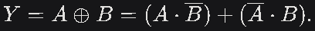
* Truth Table:

| A | B | Y (A ⊕ B) |
| --- | --- | --- |
| 0 | 0 | 0 |
| 0 | 1 | 1 |
| 1 | 0 | 1 |
| 1 | 1 | 0 |

* Example:
  + Scenario: Used in a half-adder to compute the sum of two bits.
  + Inputs: A = 1, B = 1 → Output: Y = 0 (sum = 0, carry = 1 in adder).
  + Inputs: A = 1, B = 0 → Output: Y = 1 (sum = 1, no carry).
* **Application:** Common in arithmetic circuits (e.g., adders) and error detection (e.g., parity checks).

**7. XNOR Gate (Derived Gate)**

* **Description:** Outputs 1 if all inputs are the same (even number of 1s, inverse of XOR).
* **Boolean Expression:** 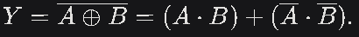
* Truth Table:

| A | B | Y (¬(A ⊕ B)) |
| --- | --- | --- |
| 0 | 0 | 1 |
| 0 | 1 | 0 |
| 1 | 0 | 0 |
| 1 | 1 | 1 |

* Example:
  + Scenario: Used in a comparator to check if two bits are equal.
  + Inputs: A = 1, B = 1 → Output: Y = 1 (bits are equal).
  + Inputs: A = 1, B = 0 → Output: Y = 0 (bits are not equal).
* **Application:** Used in equality checks and error-correcting codes.

**Examples in Context**

**1. AND Gate Example: Traffic Light Control**

* **Scenario:** A traffic light turns green only if both a pedestrian button (A) and a vehicle sensor (B) are activated.
* **Logic:** Y = A · B
* **Inputs:** 
  + A = 1 (button pressed), B = 1 (vehicle present) → Y = 1 (green light).
  + A = 0 (button not pressed), B = 1 → Y = 0 (no green light).

**2. OR Gate Example: Alarm System**

* **Scenario:** An alarm triggers if either a door sensor (A) or a window sensor (B) is activated.
* **Logic:** Y = A + B
* **Inputs:** 
  + A = 1 (door open), B = 0 (window closed) → Y = 1 (alarm on).
  + A = 0, B = 0 → Y = 0 (alarm off).

**3. NOT Gate Example: Inverter Circuit**

* **Scenario:** A circuit inverts a power signal to control a device.
* **Logic:** Y = ¬A
* **Inputs:** 
  + A = 1 (power on) → Y = 0 (device off).
  + A = 0 (power off) → Y = 1 (device on).

**4. NAND Gate Example: Safety Lock**

* **Scenario:** A machine stops if both emergency buttons (A and B) are pressed.
* **Logic:** Y = ¬(A · B)
* **Inputs:** 
  + A = 1, B = 1 → Y = 0 (machine stops).
  + A = 0, B = 1 → Y = 1 (machine runs).

**5. NOR Gate Example: System Shutdown**

* **Scenario:** A system shuts down only if no inputs (e.g., power signals A and B) are active.
* **Logic:** Y = ¬(A + B)
* **Inputs:** 
  + A = 0, B = 0 → Y = 1 (system off).
  + A = 1, B = 0 → Y = 0 (system on).

**6. XOR Gate Example: Half Adder**

* **Scenario:** In a half-adder, XOR computes the sum of two bits (A and B).
* **Logic:** Y = A ⊕ B
* **Inputs:** 
  + A = 1, B = 1 → Y = 0 (sum = 0, carry = 1).
  + A = 1, B = 0 → Y = 1 (sum = 1, no carry).

**7. XNOR Gate Example: Bit Comparator**

* **Scenario:** A circuit checks if two bits (A and B) are equal.
* **Logic:** Y = ¬(A ⊕ B)
* **Inputs:** 
  + A = 0, B = 0 → Y = 1 (bits equal).
  + A = 1, B = 0 → Y = 0 (bits not equal).

**Applications of Logic Gates**

* **Digital Circuits:** Logic gates form the basis of CPUs, memory, and other hardware components.
* **Arithmetic Circuits:** XOR and AND gates are used in adders and subtractors.
* **Control Systems:** AND, OR, and NOT gates implement decision-making logic (e.g., in automation).
* **Universal Gates**: NAND and NOR reduce manufacturing costs by allowing all logic to be built from one gate type.
* **Error Detection:** XOR and XNOR are used in parity checks and comparators.
* **Cryptography:** Logic gates manipulate binary data for encryption algorithms.

• **Safety Thermostats**:

* **Function**: A thermostat may use an AND gate to activate a heater only if the temperature is below a threshold AND a user has enabled the heating system.
* **Example**:
  + Inputs: A = 1 (temperature < 20°C), B = 1 (heater switch ON).
  + Logic: Y = A · B (AND gate).
  + Output: Y = 1 (heater turns ON).
  + If A = 0 (temperature ≥ 20°C), Y = 0 (heater stays OFF).

• **Push-Button Locks**:

* **Function**: A lock may use a combination of AND and OR gates to unlock only if the correct sequence of buttons is pressed.
* **Example**:
  + Inputs: A = 1 (button 1 pressed), B = 1 (button 2 pressed).
  + Logic: Y = A · B (AND gate, both buttons must be pressed).
  + Output: Y = 1 (lock opens).
  + If A = 0 or B = 0, Y = 0 (lock remains closed).

• **Automatic Watering Systems**:

* **Function**: An OR gate may activate a sprinkler if either a timer indicates watering time OR a soil moisture sensor detects dryness.
* **Example**:
  + Inputs: A = 1 (timer active), B = 0 (soil not dry).
  + Logic: Y = A + B (OR gate).
  + Output: Y = 1 (sprinkler ON).
  + If A = 0 and B = 0, Y = 0 (sprinkler OFF).

• **Light-Activated Burglar Alarms**:

* **Function**: A NOR gate might trigger an alarm only if no light is detected (e.g., in darkness, indicating a potential break-in).
* **Example**:
  + Inputs: A = 0 (no light detected), B = 0 (no secondary sensor triggered).
  + Logic: Y = ¬(A + B) (NOR gate).
  + Output: Y = 1 (alarm ON).
  + If A = 1 (light detected), Y = 0 (alarm OFF).

• **Components of Chips**:

* **Function**: Logic gates are combined in ICs to perform tasks like arithmetic operations, memory storage, and signal processing.
* **Example**: In a CPU, an Arithmetic Logic Unit (ALU) uses XOR and AND gates to perform addition:
  + For a half-adder: Sum = A ⊕ B, Carry = A · B.
  + Inputs: A = 1, B = 1 → Sum = 0 (XOR), Carry = 1 (AND).
  + This enables binary addition (e.g., 1 + 1 = 10 in binary).

• **Complex Gadgets and Systems**:

* **Function**: Logic gates are used in satellites, robots, and IoT devices to process data and control operations.
* **Example**: In a robotic arm, logic gates combine inputs from sensors (e.g., position, pressure) to decide movements:
  + Logic: Y = (Sensor1 · Sensor2) + ¬Sensor3 (move arm if both position and pressure are correct OR no obstacle is detected).
  + Inputs: Sensor1 = 1, Sensor2 = 1, Sensor3 = 0 → Y = 1 (arm moves).

**Decision-Making in Simple Devices**

Logic gates enable devices to make decisions based on logical conditions, making them suitable for automation and control systems.

* **Burglar Alarms, Buzzers, Switches, and Street Lights**:
  + **Function**: Gates process inputs to trigger actions (e.g., turn on a light or sound an alarm).
  + **Example**: A street light system uses an OR gate to turn on the light if it’s dark OR a manual override is activated.
    - Inputs: A = 1 (darkness detected), B = 0 (no override).
    - Logic: Y = A + B (OR gate).
    - Output: Y = 1 (light ON).

**Data Transport, Calculation, and Processing**

Logic gates are critical for manipulating binary data in computing and communication systems.

* **Data Transport**:
  + **Function**: Gates control data flow in networks (e.g., routing packets in IP networks).
  + **Example**: A multiplexer uses AND and OR gates to select one data input to send to an output line based on a control signal.
    - Logic: Y = (A · S) + (B · ¬S), where S is the selector.
    - Inputs: A = 1, B = 0, S = 1 → Y = 1 (selects A).
* **Calculation**:
  + **Function**: Gates perform arithmetic in ALUs and calculators.
  + **Example**: A full-adder uses XOR, AND, and OR gates to add three bits (A, B, Carry-in):
    - Sum = A ⊕ B ⊕ Carry-in, Carry-out = (A · B) + (B · Carry-in) + (A · Carry-in).
    - Inputs: A = 1, B = 1, Carry-in = 1 → Sum = 1, Carry-out = 1 (1 + 1 + 1 = 11 in binary).
* **Data Processing**:
  + **Function**: Gates manipulate data in memory and registers.
  + **Example**: A flip-flop (memory element) uses NAND gates to store a bit:
    - Inputs: Set = 1, Reset = 0 → Output = 1 (stores 1).
* **Transistor-Transistor Logic (TTL) and CMOS**:
  + **Function**: Modern ICs use TTL or CMOS technology, which rely on logic gates for low-power, high-speed processing.
  + **Example**: A CMOS NAND gate uses transistors to implement ¬(A · B), reducing power consumption in smartphones.

**The Role of Logic Circuits in Computer Science**

Logic circuits, built from interconnected logic gates, are the backbone of digital systems. They enable the functionality of all digital devices, from simple calculators to complex supercomputers. Their role in computer science includes:

1. **Core Building Blocks**:
   * Logic circuits form the foundation of processors (CPUs), memory units, and input/output systems.
   * **Example**: In a CPU, logic circuits implement the ALU, which performs arithmetic and logical operations using gates like XOR and AND.
2. **Universal Functionality**:
   * Universal gates (NAND, NOR) allow any logical function to be implemented, making them essential for designing flexible and cost-effective circuits.
   * **Example**: A NAND-based circuit can implement a complete processor, as NAND gates can replicate AND, OR, and NOT operations.
3. **Data Processing and Storage**:
   * Logic circuits process binary data in registers, memory, and controllers.
   * **Example**: A memory cell uses NOR gates in an SRAM configuration to store a bit, enabling fast data access in RAM.
4. **Control Systems**:
   * Logic circuits implement control logic in devices like microcontrollers and embedded systems.
   * **Example**: In a microcontroller, logic gates process sensor inputs to control actuators (e.g., turning on a motor).
5. **Complex Systems**:
   * Logic circuits power advanced systems like networks, GPUs, and AI hardware.
   * **Example**: In a neural network chip, logic gates perform matrix multiplications using parallel ALUs.

**1.2.2: Applying Boolean logic gates**

**1. Laws of Boolean Algebra**

The Boolean algebra is governed by certain well-developed rules and laws.

**Types of Boolean Laws**

There are six types of Boolean Laws.

**Commutative Laws**

**Explanation**

The commutative laws state that the order of the variables in an AND or OR operation does not affect the result. This means you can swap the operands without changing the output, similar to how addition and multiplication work in arithmetic.

**Boolean Expressions**

* For AND: $A⋅B=B⋅A$
* For OR: $A+B=B+A$

**Examples**

1. **AND Example**:
   * Expression: $A⋅B$ vs. $B⋅A$
   * Scenario: In a digital circuit, an output Y is 1 if both inputs A (switch 1) and B (switch 2) are 1.
     + Inputs: A = 1, B = 0 → $Y=1⋅0=0$
     + Swap: $Y=0⋅1=0$ (same result).
   * Truth Table Verification: The table for A · B is identical to B · A (e.g., 10 → 0, 01 → 0).
2. **OR Example**:
   * Expression: $A+B$ vs. $B+A$
   * Scenario: An alarm sounds if either sensor A or B detects motion.
     + Inputs: A = 1, B = 0 → $Y=1+0=1$
     + Swap: $Y=0+1=1$ (same result).
   * Application: Allows flexible wiring in circuits without affecting functionality.

**Associative Laws**

**Explanation**

The associative laws allow the grouping of variables in AND or OR operations to be changed without affecting the result. This is useful for operations involving three or more variables, enabling different parenthetical arrangements.

**Boolean Expressions**

* For AND: $(A⋅B)⋅C=A⋅(B⋅C)$
* For OR: $(A+B)+C=A+(B+C)$

**Examples**

1. **AND Example**:
   * Expression: $(A⋅B)⋅C$ vs. $A⋅(B⋅C)$
   * Scenario: A security system requires all three codes (A, B, C) to be correct to unlock.
     + Inputs: A = 1, B = 1, C = 0 → $(1⋅1)⋅0=1⋅0=0$
     + Regroup: $1⋅(1⋅0)=1⋅0=0$ (same).
   * Truth Table: Output is 1 only if all are 1, grouping irrelevant.
2. **OR Example**:
   * Expression: $(A+B)+C$ vs. $A+(B+C)$
   * Scenario: A light turns on if any of three buttons (A, B, C) is pressed.
     + Inputs: A = 0, B = 1, C = 0 → $(0+1)+0=1+0=1$
     + Regroup: $0+(1+0)=0+1=1$ (same).
   * Application: Simplifies multi-input gate designs in electronics.[faculty.uml.edu](https://faculty.uml.edu/anh_Tran/Course_Materials/Chpt_03.pdf)

**Distributive Laws**

**Explanation**

The distributive laws allow one operation to be distributed over another, similar to distributing multiplication over addition in arithmetic. This helps in factoring and expanding Boolean expressions for simplification.

**Boolean Expressions**

$A⋅(B+C)=(A⋅B)+(A⋅C)$

$A+(B⋅C)=(A+B)⋅(A+C)$

**Examples**

1. **AND over OR Example**:
   * Expression: $A⋅(B+C)$ vs. $(A⋅B)+(A⋅C)$
   * Scenario: Output Y is 1 if condition A is true AND either B or C is true (e.g., access granted if user is admin AND has either key or password).
     + Inputs: A = 1, B = 0, C = 1 → $1⋅(0+1)=1⋅1=1$
     + Distribute: $(1⋅0)+(1⋅1)=0+1=1$ (same).
   * Application: Optimizes logic circuits by reducing gate count.
2. **OR over AND Example**:
   * Expression: $A+(B⋅C)$ vs. $(A+B)⋅(A+C)$
   * Scenario: System activates if A is true OR both B and C are true (e.g., backup power).
     + Inputs: A = 0, B = 1, C = 1 → $0+(1⋅1)=0+1=1$
     + Distribute: $(0+1)⋅(0+1)=1⋅1=1$ (same).
   * Truth Table: Matches for all inputs.[study.madeeasy.in](https://study.madeeasy.in/ee/boolean-algebra/laws-of-boolean-algebra/)

**Idempotence Laws**

**Explanation**

The idempotence laws state that applying the same variable multiple times in an AND or OR operation yields the same result as using it once. This eliminates redundancy in expressions.

**Boolean Expressions**

* For AND: $A⋅A=A$
* For OR: $A+A=A$

**Examples**

1. **AND Example**:
   * Expression: $A⋅A=A$
   * Scenario: A circuit checks the same signal A twice (redundant).
     + Input: A = 1 → $1⋅1=1$ (equals A).
     + Input: A = 0 → $0⋅0=0$ (equals A).
   * Application: Removes duplicate AND gates in optimization.
2. **OR Example**:
   * Expression: $A+A=A$
   * Scenario: An output is triggered if sensor A detects something (repeated check unnecessary).
     + Input: A = 1 → $1+1=1$ (equals A).
     + Input: A = 0 → $0+0=0$ (equals A).
   * Truth Table: Always matches A.[geeksforgeeks.org](https://www.geeksforgeeks.org/digital-logic/boolean-algebra/)

**Absorption Laws**

**Explanation**

The absorption laws simplify expressions by "absorbing" redundant terms. They link a variable with a combination involving itself, reducing complexity.

**Boolean Expressions**

$A+(A⋅B)=A$

$A⋅(A+B)=A$

**Examples**

1. **OR Absorption Example**:
   * Expression: $A+(A⋅B)=A$
   * Scenario: Output Y is A OR (A AND B), which simplifies to just A (e.g., always grant access if A is true, regardless of B if A is involved).
     + Inputs: A = 1, B = 0 → $1+(1⋅0)=1+0=1$ (equals A).
     + Inputs: A = 0, B = 1 → $0+(0⋅1)=0+0=0$ (equals A).
   * Application: Reduces unnecessary terms in circuit design.
2. **AND Absorption Example**:
   * Expression: $A⋅(A+B)=A$
   * Scenario: Y is A AND (A OR B), simplifying to A.
     + Inputs: A = 1, B = 1 → $1⋅(1+1)=1⋅1=1$ (equals A).
     + Inputs: A = 0, B = 1 → $0⋅(0+1)=0⋅1=0$ (equals A).
   * Truth Table: Always equals A.

**Involutionary Law**

**Explanation**

The involutionary law (also known as the double negation or involution law) states that applying negation twice to a variable returns the original variable. It deals with the complement operation.

**Boolean Expression**

* $\overset{‾}{\overset{‾}{A}}=A$ (or ¬(¬A) = A)

**Examples**

1. **Basic Example**:
   * Expression: $\overset{‾}{\overset{‾}{A}}=A$
   * Scenario: In a circuit, a signal A is inverted twice (two NOT gates in series).
     + Input: A = 1 → ¬A = 0, ¬(¬A) = ¬0 = 1 (back to A).
     + Input: A = 0 → ¬A = 1, ¬(¬A) = ¬1 = 0 (back to A).

|  |  |  |  |
| --- | --- | --- | --- |
| **Rule** | **Boolean Expression** | **Description** | **Application Example** |
| **Product Rules** |  |  |  |
| Idempotent (AND) | $$A⋅A=A$$ | ANDing a variable with itself yields itself | Remove duplicate AND gates |
| Identity (AND) | $A⋅1=A$, $A⋅0=0$ | AND with 1 preserves, with 0 nullifies | Model enable/disable signals |
| Complement (AND) | $$A⋅\overset{‾}{A}=0$$ | AND with complement is always false | Prevent conflicting states |
| **Absorption Rules** |  |  |  |
| First Absorption | $$A+(A⋅B)=A$$ | OR with AND of same variable simplifies to variable | Eliminate redundant AND terms |
| Second Absorption | $$A⋅(A+B)=A$$ | AND with OR of same variable simplifies to variable | Eliminate redundant OR terms |

1. **Boolean Algebraic Theorems**

De Morgan's Theorem is a pair of fundamental rules in Boolean algebra that describe how to transform logical expressions involving AND, OR, and NOT operations. These theorems are essential for simplifying Boolean expressions, optimizing digital circuits, and transforming logic gates (e.g., converting between AND and OR operations with negations). They provide a way to express the complement (negation) of a logical expression in an equivalent form, which is particularly useful in circuit design and logical analysis.

De Morgan's Theorem consists of two rules that relate the complement of a product (AND) or sum (OR) to the sum or product of the complements, respectively. These theorems are widely used in digital electronics, computer science, and logic simplification to reduce the number of gates or to convert between different gate types (e.g., NAND to OR, NOR to AND).

**De Morgan's Theorem**

**The Two Theorems**

1. **First Theorem**:
   * **Statement**: The complement of a product (AND) of variables is equal to the sum (OR) of their complements.
   * **Boolean Expression**: $\overset{‾}{A⋅B}=\overset{‾}{A}+\overset{‾}{B}$
   * **Interpretation**: The negation of an AND operation is equivalent to an OR operation on the negated inputs.
2. **Second Theorem**:
   * **Statement**: The complement of a sum (OR) of variables is equal to the product (AND) of their complements.
   * **Boolean Expression**: $\overset{‾}{A+B}=\overset{‾}{A}⋅\overset{‾}{B}$
   * **Interpretation**: The negation of an OR operation is equivalent to an AND operation on the negated inputs.

**Explanation and Examples**

**1. First Theorem: $\overset{‾}{A⋅B}=\overset{‾}{A}+\overset{‾}{B}$**

**Explanation**

* This theorem states that negating the result of an AND operation (A · B) is the same as ORing the negated inputs ( $\overset{‾}{A}$ or $\overset{‾}{B}$).
* In terms of logic gates, a NAND gate (which outputs $\overset{‾}{A⋅B}$) is equivalent to an OR gate with inverted inputs ($\overset{‾}{A}+\overset{‾}{B}$).

**Truth Table Verification**

To confirm the equivalence, compare the truth tables for both sides:

|  |  |  |  |  |  |  |
| --- | --- | --- | --- | --- | --- | --- |
| **A** | **B** | **A · B** | $$\overset{‾}{A⋅B}$$ | $$\overset{‾}{A}$$ | $$\overset{‾}{B}$$ | $$\overset{‾}{A}+\overset{‾}{B}$$ |
| 0 | 0 | 0 | 1 | 1 | 1 | 1 |
| 0 | 1 | 0 | 1 | 1 | 0 | 1 |
| 1 | 0 | 0 | 1 | 0 | 1 | 1 |
| 1 | 1 | 1 | 0 | 0 | 0 | 0 |

* The columns for $\overset{‾}{A⋅B}$ (NAND) and $\overset{‾}{A}+\overset{‾}{B}$ (OR with negated inputs) are identical, proving the theorem.

**Example 1: Simplifying an Expression**

* **Expression**: Simplify $\overset{‾}{A⋅B}$.
* **Using Theorem**: $\overset{‾}{A⋅B}=\overset{‾}{A}+\overset{‾}{B}$.
* **Scenario**: A circuit outputs 0 only when both inputs A and B are 1 (NAND gate).
  + Inputs: A = 1, B = 1 → $A⋅B=1$, $\overset{‾}{A⋅B}=0$.
  + Using theorem: $\overset{‾}{A}=0$, $\overset{‾}{B}=0$, $\overset{‾}{A}+\overset{‾}{B}=0+0=0$.
  + Inputs: A = 0, B = 1 → $A⋅B=0$, $\overset{‾}{A⋅B}=1$.
  + Using theorem: $\overset{‾}{A}=1$, $\overset{‾}{B}=0$, $\overset{‾}{A}+\overset{‾}{B}=1+0=1$.
* **Application**: Converts a NAND gate to an OR gate with inverters, useful for circuit optimization when only OR gates are available.

**2. Second Theorem: $\overset{‾}{A+B}=\overset{‾}{A}⋅\overset{‾}{B}$**

**Explanation**

* This theorem states that negating the result of an OR operation (A + B) is the same as ANDing the negated inputs ( $\overset{‾}{A}$ and $\overset{‾}{B}$).
* In terms of logic gates, a NOR gate (which outputs $\overset{‾}{A+B}$) is equivalent to an AND gate with inverted inputs ($\overset{‾}{A}⋅\overset{‾}{B}$).

**Truth Table Verification**

|  |  |  |  |  |  |  |
| --- | --- | --- | --- | --- | --- | --- |
| **A** | **B** | **A + B** | $$\overset{‾}{A+B}$$ | $$\overset{‾}{A}$$ | $$\overset{‾}{B}$$ | $$\overset{‾}{A}⋅\overset{‾}{B}$$ |
| 0 | 0 | 0 | 1 | 1 | 1 | 1 |
| 0 | 1 | 1 | 0 | 1 | 0 | 0 |
| 1 | 0 | 1 | 0 | 0 | 1 | 0 |
| 1 | 1 | 1 | 0 | 0 | 0 | 0 |

* The columns for $\overset{‾}{A+B}$ (NOR) and $\overset{‾}{A}⋅\overset{‾}{B}$ (AND with negated inputs) are identical, proving the theorem.

**Example 1: Simplifying an Expression**

* **Expression**: Simplify $\overset{‾}{A+B}$.
* **Using Theorem**: $\overset{‾}{A+B}=\overset{‾}{A}⋅\overset{‾}{B}$.
* **Scenario**: A circuit outputs 1 only when neither A nor B is 1 (NOR gate).
  + Inputs: A = 0, B = 0 → $A+B=0$, $\overset{‾}{A+B}=1$.
  + Using theorem: $\overset{‾}{A}=1$, $\overset{‾}{B}=1$, $\overset{‾}{A}⋅\overset{‾}{B}=1⋅1=1$.
  + Inputs: A = 1, B = 0 → $A+B=1$, $\overset{‾}{A+B}=0$.
  + Using theorem: $\overset{‾}{A}=0$, $\overset{‾}{B}=1$, $\overset{‾}{A}⋅\overset{‾}{B}=0⋅1=0$.
* **Application**: Converts a NOR gate to an AND gate with inverters, useful when optimizing with AND gates.

**Generalization to Multiple Variables**

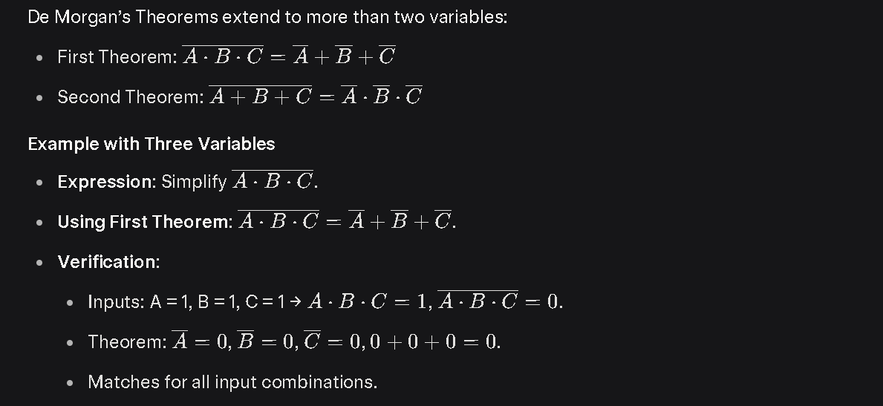

|  |  |  |  |
| --- | --- | --- | --- |
| **Theorem** | **Boolean Expression** | **Logic Gate Equivalence** | **Application** |
| First Theorem | $$\overset{‾}{A⋅B}=\overset{‾}{A}+\overset{‾}{B}$$ | NAND = OR with inverted inputs | Convert NAND to OR, simplify expressions |
| Second Theorem | $$\overset{‾}{A+B}=\overset{‾}{A}⋅\overset{‾}{B}$$ | NOR = AND with inverted inputs | Convert NOR to AND, optimize circuits |

**Laws of Boolean Algebra Example No1**

Using the above laws, simplify the following expression: (A + B)(A + C)

(A + B).(A + C)

= A.A + A.C + A.B + B.C Distributive law

A + A.C + A.B + B.C Idempotent AND law (A.A = A)

A(1 + C) + A.B + B.C Distributive law

A.1 + A.B + B.C Identity OR law (1 + C = 1)

A(1 + B) + B.C Distributive law

A.1 + B.C Identity OR law (1 + B = 1)

A + (B.C) Identity AND law (A.1 = A)

=

Then the expression: (A + B)(A + C) can be simplified to A + (B.C) as in the Distributive law.

**Example 2**

Using Boolean algebra techniques, simplify this expression: AB + A(B + C) + B(B + C)

Solution

Step 1: Apply the distributive law to the second and third terms in the expression, as follows:

AB + AB + AC + BB + BC

Step 2: Apply rule 7 (BB = B) to the fourth term. AB + AB + AC + B + BC

Step 3: Apply rule 5 (AB + AB = AB) to the first two terms. AB + AC + B + BC

Step 4: Apply rule 10 (B + BC = B) to the last two terms. AB + AC + B

Step 5: Apply rule 10 (AB + B = B) to the first and third terms. B+AC

At this point the expression is simplified as much as possible.

The Truth table

| **A** | **B** | **C** | **A · B** | **B + C** | **A · (B + C)** | **B · (B + C)** | **Original Y** | **A · C** | **B + A · C** |
| --- | --- | --- | --- | --- | --- | --- | --- | --- | --- |
| 0 | 0 | 0 | 0 | 0 | 0 | 0 | 0 | 0 | 0 |
| 0 | 0 | 1 | 0 | 1 | 0 | 0 | 0 | 0 | 0 |
| 0 | 1 | 0 | 0 | 1 | 0 | 1 | 1 | 0 | 1 |
| 0 | 1 | 1 | 0 | 1 | 0 | 1 | 1 | 0 | 1 |
| 1 | 0 | 0 | 0 | 0 | 0 | 0 | 0 | 0 | 0 |
| 1 | 0 | 1 | 0 | 1 | 1 | 0 | 1 | 1 | 1 |
| 1 | 1 | 0 | 1 | 1 | 1 | 1 | 1 | 0 | 1 |
| 1 | 1 | 1 | 1 | 1 | 1 | 1 | 1 | 1 | 1 |

**Example 3:**

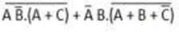 Also, can be written as **(AB'.(A + C))'+ A'B. (A + B + C')'**

**Solution**

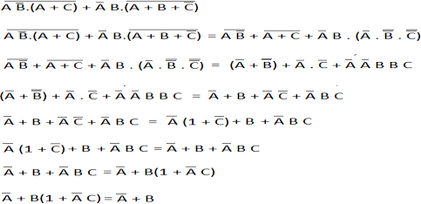

Or you can do it in this way:

**Step-by-Step Simplification**

Let’s denote the expression as: $Y=(AB^{'}⋅(A+C))^{'}+A^{'}B⋅(A+B+C^{'})^{'}$

**Step 1: Apply De Morgan’s Theorem to the Complemented Terms**

The expression contains two negated sub-expressions: $(AB^{'}⋅(A+C))^{'}$ and $(A+B+C^{'})^{'}$. We’ll use De Morgan’s Theorem to simplify these.

* **First term**: $(AB^{'}⋅(A+C))^{'}$
  + De Morgan’s Theorem states: $\overset{‾}{X⋅Y}=\overset{‾}{X}+\overset{‾}{Y}$.
  + Here, $X=AB^{'}$ and $Y=A+C$, so: $$(AB^{'}⋅(A+C))^{'}=\overset{‾}{AB^{'}⋅(A+C)}=\overset{‾}{AB^{'}}+\overset{‾}{A+C}$$
  + Apply De Morgan’s to each part:
    - $\overset{‾}{AB^{'}}=\overset{‾}{A}+\overset{‾}{B^{'}}=A^{'}+B$ (since $\overset{‾}{B^{'}}=B$).
    - $\overset{‾}{A+C}=\overset{‾}{A}⋅\overset{‾}{C}=A^{'}⋅C^{'}$.
  + Combine: $$\overset{‾}{AB^{'}}+\overset{‾}{A+C}=(A^{'}+B)+(A^{'}⋅C^{'})$$
* **Second term**: $(A+B+C^{'})^{'}$
  + Apply De Morgan’s: $\overset{‾}{A+B+C^{'}}=\overset{‾}{A}⋅\overset{‾}{B}⋅\overset{‾}{C^{'}}=A^{'}⋅B^{'}⋅C$ (since $\overset{‾}{C^{'}}=C$).
  + So, the second term becomes: $$A^{'}B⋅(A+B+C^{'})^{'}=A^{'}B⋅(A^{'}⋅B^{'}⋅C)=A^{'}⋅A^{'}⋅B⋅B^{'}⋅C$$
  + Simplify using the **Idempotent Law** ($A^{'}⋅A^{'}=A^{'}$) and **Complement Law** ($B⋅B^{'}=0$): $$A^{'}⋅A^{'}⋅B⋅B^{'}⋅C=A^{'}⋅0⋅C=0$$
  + Thus, the second term simplifies to **0**.

**Step 2: Combine the Terms**

The expression now is:

$$Y=(A^{'}+B+A^{'}⋅C^{'})+0$$

* The **Identity Law** ($X+0=X$) eliminates the 0: $$Y=A^{'}+B+A^{'}⋅C^{'}$$

**Step 3: Simplify the Remaining Expression**

Now, simplify $A^{'}+B+A^{'}⋅C^{'}$:

* Notice the term $A^{'}+A^{'}⋅C^{'}$.
* Apply the **Absorption Law**: $A+A⋅B=A$.
  + Here, let’s rewrite $A^{'}+A^{'}⋅C^{'}$: $$A^{'}+A^{'}⋅C^{'}=A^{'}⋅(1+C^{'})$$
  + Using the **Identity Law** ($1+C^{'}=1$), since ORing with 1 yields 1: $$A^{'}⋅(1+C^{'})=A^{'}⋅1=A^{'}$$
* Thus: $$A^{'}+A^{'}⋅C^{'}=A^{'}$$
* The expression becomes: $$Y=A^{'}+B+A^{'}=A^{'}+A^{'}+B$$
* Apply the **Idempotent Law** ($A^{'}+A^{'}=A^{'}$): $$Y=A^{'}+B$$

We’ll compute the truth table for both, focusing on variables A, B, and C.

|  |  |  |  |  |  |  |  |  |  |  |  |  |  |  |  |
| --- | --- | --- | --- | --- | --- | --- | --- | --- | --- | --- | --- | --- | --- | --- | --- |
| **A** | **B** | **C** | **B'** | **A + C** | **AB'** | **AB' · (A + C)** | **(AB' · (A + C))'** | **C'** | **A + B + C'** | **(A + B + C')'** | **A'B** | **A'B · (A + B + C')'** | **Original Y** | **A'** | **A' + B** |
| 0 | 0 | 0 | 1 | 0 | 0 | 0 | 1 | 1 | 1 | 0 | 0 | 0 | 1 | 1 | 1 |
| 0 | 0 | 1 | 1 | 1 | 0 | 0 | 1 | 0 | 0 | 1 | 0 | 0 | 1 | 1 | 1 |
| 0 | 1 | 0 | 0 | 0 | 0 | 0 | 1 | 1 | 1 | 0 | 1 | 0 | 1 | 1 | 1 |
| 0 | 1 | 1 | 0 | 1 | 0 | 0 | 1 | 0 | 1 | 0 | 1 | 0 | 1 | 1 | 1 |
| 1 | 0 | 0 | 1 | 1 | 1 | 1 | 0 | 1 | 1 | 0 | 0 | 0 | 0 | 0 | 0 |
| 1 | 0 | 1 | 1 | 1 | 1 | 1 | 0 | 0 | 1 | 0 | 0 | 0 | 0 | 0 | 0 |
| 1 | 1 | 0 | 0 | 1 | 0 | 0 | 1 | 1 | 1 | 0 | 0 | 0 | 1 | 0 | 1 |
| 1 | 1 | 1 | 0 | 1 | 0 | 0 | 1 | 0 | 1 | 0 | 0 | 0 | 1 | 0 | 1 |

**COMPLEMENT FOR BINARY NUMBER**

Complements are used in digital computers to simplify the subtraction operation and for the logical manipulations. There are two types of complements.

The two types of complements for the binary system are 1's complement and 2's complement.

**1's complement**

The 1's complement of a number is found by changing all 1's to 0's and all 0's to 1's. This is called taking complement or 1's complement. Example of 1's Complement is as follows.

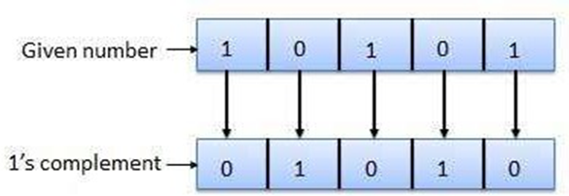

**2's complement**

The 2's complement of binary number is obtained by adding 1 to the Least Significant Bit (LSB) of 1's complement of the number.

2's complement = 1's complement + 1 Example of 2's Complement is as follows.

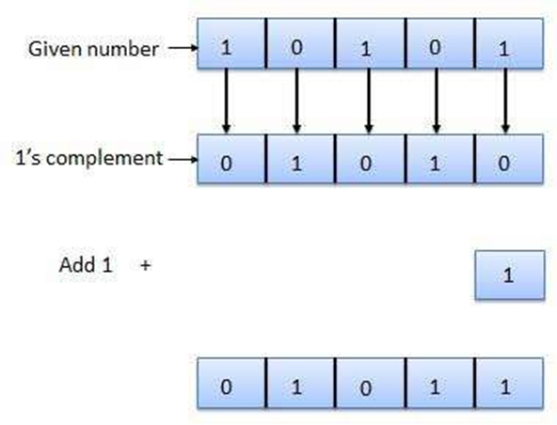

In two's complement form, a negative number is the 2's complement of its positive number with the subtraction of two numbers being A – B = A + ( 2's complement of B ). Two's complement is one's complement + 1.

The statement has three key parts:

1. **In two's complement form, a negative number is the 2's complement of its positive number.**
2. **The subtraction of two numbers is performed as $A-B=A+(2^{'}s\text{ complement of }B)$.**
3. **Two's complement is one's complement + 1.**

Circuits

A logic circuit can be defined as an electrical circuit that executes logical operations on one or more binary inputs to produce a single binary output.

They operate based on Boolean algebra principles, which are grounded in the truth values true and false, often represented as 1 and 0, respectively.

Logic circuits are critical in CPU microarchitecture and cores to undertake tasks such as computation, encoding, multiplexing, and memory interfacing. They also play a significant role in developing hardware like ALUs (Arithmetic Logic Units).

Circuits enable computers to do more complex operations than they could accomplish with just a single gate.

The smallest circuit is a chain of 2 logic gates. Consider this circuit:

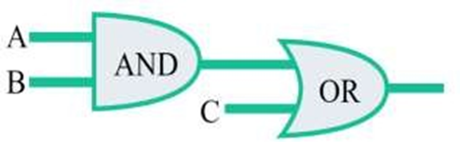

**Writing Boolean Expression to Simplify Circuits**

Our first step in simplification must be to write a Boolean expression for this circuit. This task is easily performed step by step if we start by writing sub-expressions at the output of each gate, corresponding to the respective input signals for each gate.

Remember that OR gates are equivalent to Boolean addition, while AND gates are equivalent to Boolean multiplication.

For example, I’ll write sub-expressions at the outputs of the first three gates:

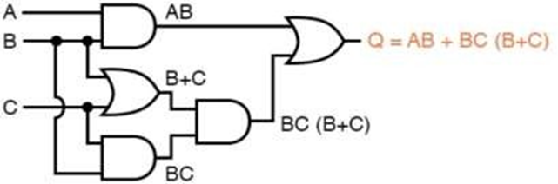

**Exercises**

* Draw a logic circuit of the following Boolean expression:
  + 1. **(A.B’) + (C+D’) + B.D’**
    2. **(A+B) . (BC+D)**
* Convert the following logic gate circuit into a Boolean expression, writing Boolean sub-expressions next to each gate output in the diagram:
  + 1. 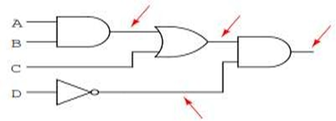
    2. 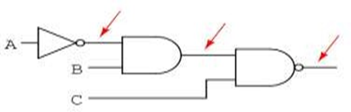
    3. 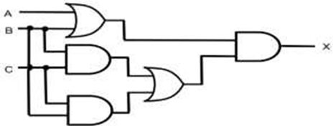

**Truth Tables**

**Definition**

A truth table is a mathematical tool in logic and digital electronics that lists all possible input combinations for a logical expression or circuit and their corresponding output values. It maps binary inputs (0 or 1, representing false or true) to outputs based on the Boolean function of a logic gate or circuit.

**Key Points**

* **Structure:** 
  + **Columns:** One for each input variable and one for the output.
  + **Rows:** Each row represents a unique combination of input values.
  + **Number of Rows:** For $n$ inputs, there are $2^{n}$ rows (e.g., 2 inputs → $2^{2}=4$ rows).
* **Purpose:** 
  + **Validation:** Confirms the behavior of a logic gate or circuit for all input combinations.
  + **Summary:** Provides a complete, concise overview of a system’s states.
  + **Design Aid: Helps designers predict and optimize circuit performance.**
* **Procedure:** 
  + Create a table with columns for each input and one for the output.
  + Calculate rows: $2^{n}$ for $n$ inputs.
  + List all possible input combinations (e.g., for 2 inputs: 00, 01, 10, 11).
  + Compute the output for each row based on the logic gate or circuit’s Boolean expression.

**Example**

* **Circuit:** AND gate with inputs A and B, output $Y=A⋅B$.
* **Truth Table** (2 inputs → 4 rows):
  1. 
  2. 

Solution:



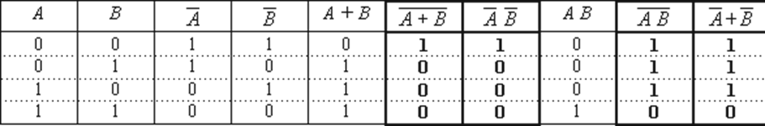

**Indicative content 1.3: Use of Data Types on Variables**

**1. Variables and Data types in JavaScript**

* 1. [**Variables**](https://www.geeksforgeeks.org/javascript-variables/)

In JavaScript, Variable is a container for Storing Data. Also, we can say that variable is a memory zone used to store and manage data.

JavaScript Variables can be declared in 4 ways:

* Automatically: Variables are created when first assigned (e.g.,x = 5;). Not recommended can lead to bugs and global scope pollution.
* Using var: Function-scoped; used in legacy code (pre-2015). Avoid in modern JavaScript.
* Using let: Block-scoped; value can be reassigned. Preferred for mutable data.
* Using const: Block-scoped; value cannot be reassigned. Use for constants or fixed references.

Examples:

*// Automatic (avoid)*

*x = 5;*

*y = 6;*

*z = x + y;*

*// Using var (legacy)*

*var x = 5, y = 6, z = x + y;*

*// Using let (mutable)*

*let x = 5, y = 6;*

*let z = x + y;*

*// Using const (immutable)*

*const price1 = 5;*

*const price2 = 6;*

*let total = price1 + price2; // total can change; prices cannot*

The two variables price1 and price2 are declared with the const keyword. These are constant values and cannot be changed.

The variable total is declared with the let keyword. The value total can be changed.

A variable to be used must first be declared. Declare a variable; means create it by giving it a **name** and a **data type**.

Advantages of Using Variables

* Store and reuse data efficiently.
* Provide descriptive names for better code readability.
* Enable dynamic manipulation of values during program execution.
* Help manage memory allocation (handled automatically in JavaScript).
  1. **Datatype**

JavaScript is a dynamically typed language, meaning:

* You do not need to specify a data type when declaring a variable.
* The type is inferred at runtime based on the assigned value.
* A variable can hold different types over its lifetime.

Examples:

*let value = 10; // number*

*value = "Hello"; // now a string*

*value = true; // now a boolean*

To check a variable’s current type, use the typeof operator:

*let counter = 120;*

*console.log(typeof counter); // "number"*

*counter = false;*

*console.log(typeof counter); // "boolean"*

2. Two Main Categories of Data Types

A. Primitive (Built-in) Data Types

Primitive data types are predefined types of data, which are supported by the programming language.

|  |  |  |
| --- | --- | --- |
| Type | Description | Example |
| number | Represents integers and floating-point numbers. | let age = 25; let pi = 3.14; |
| string | Text enclosed in ' ' or " ". | let name = "Alice"; |
| Boolean | Logical values: true or false. | let isActive = true; |
| undefined | A variable declared but not assigned a value. | let x; // x is undefined |
| null | Intentional absence of any object value. | let user = null; |
| BigInt | Arbitrary large integers (ES2020+). | let big = 9007199254740991n; |
| Symbol | Unique, immutable identifiers (ES2015+). | let id = Symbol("id"); |

Note: typeof null returns "object" — a known historical bug in JavaScript.

B. Non-Primitive (Reference) Data Types

These store references to memory locations and can hold complex data.

The data type that are derived from primary data types are known as non- primitive data type.

Non-primitive data types are not defined by the programming language, but are instead created by the programmer.

|  |  |  |
| --- | --- | --- |
| Type | Description | Example |
| `Object` | Collection of key-value pairs. | let person = { name: "John", age: 30 }; |
| `Array` | Ordered list of values (indexed). | let colors = ["red", "green", "blue"]; |

🔹 Non-primitive types are mutable—their contents can be changed after creation.

3. Key Concepts & Special Cases

Dynamic Typing in Action

*let data = 100; // number*

*data = "text"; // string*

*data = [1, 2, 3]; // array (object)*

The undefined Type

* Default value for declared but uninitialized variables.
* typeof undeclaredVariable also returns "undefined".

*let count;*

*console.log(count); // undefined*

*console.log(typeof count); // "undefined"*

The null Type

* Represents "no value" or "empty object reference".
* Despite being primitive, typeof null === "object".

*let obj = null;*

*console.log(obj == undefined); // true (loose equality)*

*console.log(obj === undefined); // false (strict equality)*

The number Type

* Handles both integers and floats.
* Uses IEEE 754 double-precision format.
* Special values:
  + Infinity / -Infinity
  + NaN (Not-a-Number)

About NaN

* Result of invalid numeric operations (e.g., "a" / 2).
* Unique properties:
  + NaN !== NaN → always false
  + Any operation with NaN returns NaN

*console.log("a" / 2); // NaN*

*console.log(NaN == NaN); // false*

*console.log(isNaN(NaN)); // true (use this to check)*

The string Type

* Immutable: once created, cannot be changed.
* Use backslash (\) to escape quotes:

*let msg = 'It\'s okay'; // Escaped single quote*

*let html = "<div class=\"box\">"; // Escaped double quote*

String modification creates a new string:

*let s = "Hello";*

*s = s + " World"; // New string created; original unchanged*

Attempting to change a character directly has no effect:

*let word = "Cat";*

*word[0] = "B";*

*console.log(word); // "Cat" (not "Bat")*

The boolean Type

* Only two values: true and false (lowercase).
* Other types can be coerced to boolean (truthy/falsy values).

*let done = false;*

*console.log(typeof done); // "boolean"*

Best Practices

* Use const by default; switch to let only when reassignment is needed.
* Avoid var and automatic declaration.
* Leverage typeof for debugging type-related issues.
* Remember: JavaScript is dynamically typed—flexible but requires careful handling.

**Indicative content 1.4: Application of JavaScript Operators**

An operator is a special symbol or keyword that performs an operation on one or more operands (values or variables).

Example:

let result = 4 + 5; // 9

* 4 and 5 → operands
* + → operator
* result → stores the outcome of the operation

JavaScript supports several types of operators, each serving a specific purpose.

**1. Arithmetic Operators**

Used to perform mathematical calculations.

|  |  |  |  |
| --- | --- | --- | --- |
| Operator | Name | Example | Result |
| + | Addition | 5 + 3 | 8 |
| - | Subtraction | 10-4 | 6 |
| * | Multiplication | 7 * 6 | 42 |
| / | Division | 15/3 | 5 |
| % | Modulus (Remainder) | 10 % 3 | 1 |
| ++ | Increment | let x = 5; x++; | x = 6 |
| -- | Decrement | let y = 8; y--; | y = 7 |
| ** | Exponentiation | 2 ** 3 | 8 |

Examples in Code

*let a = 10, b = 3;*

*console.log(a + b); // 13*

*console.log(a - b); // 7*

*console.log(a * b); // 30*

*console.log(a / b); // 3.333...*

*console.log(a % b); // 1 (remainder of 10 ÷ 3)*

*console.log(a ** b); // 1000 (10³)*

*// Increment/Decrement*

*let counter = 5;*

*console.log(++counter); // 6 (pre-increment)*

*console.log(counter--); // 6 (post-decrement, then counter = 5)*

Note:

* ++x → increment before use (pre-increment)
* x++ → use then increment (post-increment)

2. Comparison (Relational) Operators

Compare two values and return a Boolean (true or false).

|  |  |  |  |
| --- | --- | --- | --- |
| Operator | Meaning | Example | Result |
| == | Equal (loose) | 5 == "5" | TRUE |
| === | Equal (strict) | 5 === "5" | FALSE |
| != | Not equal (loose) | 5 != "6" | TRUE |
| !== | Not equal (strict) | 5 !== "5" | TRUE |
| > | Greater than | 8 > 5 | TRUE |
| < | Less than | 3 < 2 | FALSE |
| >= | Greater than or equal | 5 >= 5 | TRUE |
| <= | Less than or equal | 4 <= 3 | FALSE |

Examples

*console.log(10 == "10"); // true (type coercion)*

*console.log(10 === "10"); // false (different types)*

*console.log(7 > 5); // true*

*console.log(2 <= 2); // true*

*console.log("apple" < "banana"); // true (lexicographical comparison)*

Best Practice: Prefer === and !== to avoid unexpected type coercion.

3. Logical Operators

Used to combine or invert boolean conditions.

|  |  |  |  |
| --- | --- | --- | --- |
| Operator | Name | Description | Example |
| && | AND | Returns true if both operands are true | (5 > 3) && (2 < 4) → true |
| || | OR | Returns true if at least one is true | (5 < 3) || (2 < 4) → true |
| ! | NOT | Inverts the boolean value | !(5 == 5) → false |

Examples

*let isLoggedIn = true;*

*let hasPermission = false;*

*console.log(isLoggedIn && hasPermission); // false*

*console.log(isLoggedIn || hasPermission); // true*

*console.log(!isLoggedIn); // false*

*// Short-circuit evaluation*

*let name = "" || "Guest"; // "Guest" (falsy → fallback)*

*let access = true && "Allowed"; // "Allowed"*

Logical operators work with any type (not just booleans) using truthy/falsy rules.

4. Assignment Operators

Assign values to variables. Combine assignment with other operations.

|  |  |  |  |
| --- | --- | --- | --- |
| Operator | Equivalent To | Example | Result |
| = | Assign | x = 5 | x = 5 |
| += | Add and assign | x += 3 | x = x + 3 |
| -= | Subtract and assign | x -= 2 | x = x - 2 |
| *= | Multiply and assign | x *= 4 | x = x * 4 |
| /= | Divide and assign | x /= 2 | x = x / 2 |
| %= | Modulus and assign | x %= 3 | x = x % 3 |
| **= | Exponentiate and assign | x **= 2 | x = x² |

Examples

*let score = 10;*

*score += 5; // score = 15*

*score *= 2; // score = 30*

*score -= 10; // score = 20*

*console.log(score); // 20*

5. Conditional (Ternary) Operator

A shorthand for if...else statements.

Syntax

*condition ? valueIfTrue : valueIfFalse*

Example

*let age = 18;*

*let message = (age >= 18) ? "Adult" : "Minor";*

*console.log(message); // "Adult"*

Real-World Use

*let isMember = true;*

*let price = isMember ? 10 : 20; // Members pay $10, others $20*

Use ternary for simple conditions; avoid nesting for readability.

Operator Precedence (Quick Reference)

Operators are evaluated in a specific order (like PEMDAS in math):

1. Grouping: ( )
2. Exponentiation: **
3. Unary: ++, --, !
4. Multiplication/Division: *, /, %
5. Addition/Subtraction: +, -
6. Comparison: <, <=, >, >=
7. Equality: ==, !=, ===, !==
8. Logical AND: &&
9. Logical OR: ||
10. Conditional: ? :
11. Assignment: =, +=, etc.

Example:

*let result = 3 + 4 * 2 > 10 ? "Yes" : "No";*

*// Evaluated as: 3 + (4 * 2) → 11 → 11 > 10 → true → "Yes"*

**The typeof Operator in JavaScript**

The typeof operator is a unary operator that returns a string indicating the data type of its operand.

Syntax

*typeof operand*

*// or*

*typeof(operand)*

Both forms work the parentheses are optional but often used for readability.

Return Values of typeof

Examples in Code

**Basic Usage**

*console.log(typeof 42); // "number"*

*console.log(typeof "Hello"); // "string"*

*console.log(typeof true); // "boolean"*

*console.log(typeof undefined); // "undefined"*

*console.log(typeof { name: "Ali" }); // "object"*

*console.log(typeof [1, 2, 3]); // "object" (arrays are objects!)*

*console.log(typeof function() {}); // "function"*

*console.log(typeof Symbol('id')); // "symbol"*

*console.log(typeof 9007199254740991n); // "bigint"*

**The** null

*let user = null;*

*console.log(typeof user); // "object" ❌ (but it's not an object!)*

*// To safely check for null:*

*console.log(user === null); // true*

**Checking Undeclared Variables**

*// Declared but not initialized*

*let age;*

*console.log(typeof age); // "undefined"*

*// Undeclared variable (no error!)*

*console.log(typeof undeclaredVar); // "undefined"*

*This makes typeof safe for checking if a variable exists without throwing a ReferenceError.*

**Practical Use Cases**

**1.** Type Checking Before Operations

*function add(a, b) {*

*if (typeof a === "number" && typeof b === "number") {*

*return a + b;*

*} else {*

*console.log("Both arguments must be numbers!");*

*}*

*}*

*add(5, 3); // 8*

*add("5", 3); // Error message*

**2.** Safe Feature Detection

*if (typeof fetch !== "undefined") {*

*// Browser supports fetch API*

*fetch('/data');*

*}*

**3.** Debugging & Logging

let value = getData();

console.log(`Value: ${value}, Type: ${typeof value}`);

Best Practices

* Use typeof for basic type checks (especially for primitives).
* Never rely on typeof alone to detect null or arrays.
* Prefer === with null for null c hecks.
* Combine with other methods (Array.isArray, instanceof) for complex types.

**Indicative content 1.5: Write an Algorithm**

**1.5.1.: Description of key concepts of Algorithm fundamentals**

**1. Key concepts of algorithm fundamentals**

**Language** is a mode of communication that is used **to share ideas, opinions with each other**. For example, if we want to teach someone, we need a language that is understandable by both communicators.

To communicate with computers, programmers also need a language called Programming language.

**Programming language:** Programming language is a formal language used by computer programmer to create software programs and instruct a computer **A programming language** is a computer language that is **used by programmers (developers) to communicate with computers.**

**Natural languages** are the languages that people speak, such as English, Kinyarwanda or French. They were not designed by people (although people try to impose some order on them); they evolved naturally.

**Formal languages** are languages that are designed by people for specific applications.

**Computer Programmer:** A programmer is a person who writes computer programs.

**Source code:** Source code is the set of instructions written by a programmer using a computer programming language. This code is later translated into machine language by a compiler.

**Machine code:** Also called **machine language**, is a computer language that is directly understandable by a computer's CPU. It is composed of digital binary numbers (zeros and ones). and it is the language into which all programs must be converted before they can be run.

The source code is run through a compiler to turn it into machine code, also called object code that a computer can understand and execute. Object code consists primarily of 1s and 0s, so it isn't human-readable.

**Source Code Licensing**

Source code can be either proprietary or open. Many companies closely guard their source code. Users can use the compiled code, but they cannot see or modify it.

**Algorithm:** It is a step-by-step procedure (well-defined instructions) to solve a given problem to get an expected result.

It can be translated into a programming language to produce the result. Algorithm is not the complete code or program; it is just the core logic (solution) of a problem.

**IDE (Integrated Development)**

An IDE is a set of tools like text editor, compiler, debugger etc., that all work together to facilitate software programming. An editor is simply one tool among tools of IDE that is designed to edit text.

**Editor**

**Editors** or **Text editors** are software programs that enable the user to create and edit text files.

Ex: Dev++, Code-blocks, Dreamweaver, Notepad++, Sublime

In the field of programming, the term editor usually refers to source code editors that include many special features for writing and editing code.

Features normally associated with text editors are moving the cursor, deleting, replacing, pasting, finding and replacing, saving etc.

**High level language and Low-level language**

Generally, we write a computer program using a high-level language. A high-level language is one which is understandable by us humans.

It contains words and phrases from the English (or other) language. But a computer does not understand high-level language

It only understands program written in 0's and 1's in binary, called the machine code. A program written in high-level language is called a source code. We need to convert the source code into machine code, and this is accomplished by compilers and interpreters.

After the source code for a program has been written by a Programmer, it is compiled (i.e., converted) into machine code by a specialized program called a compiler, or by an assembler in the case of assembly language. This machine code is then stored as an executable file (i.e., a ready-to-run program) and can be executed (run) by the operating system any time.

**Compiler and Interpreter**

**Compiler:** A compiler is a computer program that translates source code into machine code

**Interpreter:** It is a computer program that executes instructions written in a programming/scripting language without requiring to be compiled into machine language.

A compiler translates the entire source code into machine code before execution, resulting in faster execution since no translation is needed during runtime. On the other hand, an interpreter translates code line by line during execution, making it easier to detect errors but potentially slowing down the program.

A **compiler** is defined as a software that transforms an entire set of source code into object code and saves it as a file before executing it. Conversely, an interpreter converts and executes source code line by line without saving it and points out errors along the way.

**2. The difference between an interpreter and a compiler is given bellow**

|  |  |
| --- | --- |
| **Interpreter** | **Compiler** |
| Translates program one statement at a time | Scans the entire program and translates it into machine code |
| It takes less amount of time to analyse the source code | It takes large amount of time to analyse the source code |
| Overall execution time is slow | Overall execution time is comparatively faster |
| No intermediate object code is generated |  |
| Execution requires low memory | Execution requires more memory |
| Continues translating the program until the first error is meet, in which case it stops. Hence debugging is easy | It generates the error message only after scanning the whole program. Hence debugging is comparatively hard |
| Programming language like python, Ruby, php and Perl use interpreters | Programming language like C, C++, C# use compiler |

**3. Types of algorithms**

There are many types of algorithms but the most important and fundamental algorithms that you must are discussed in this article.

* 1. **Brute Force Algorithm:**

This is the most basic and simplest type of algorithm.

A Brute Force Algorithm is the straightforward approach to a problem i.e., the first approach that comes to our mind on seeing the problem.

* 1. **Recursive Algorithm:**

In recursion, a problem is solved by breaking it into subproblems of the same type and calling own self repeatedly until the problem is solved with the help of a base condition.

Examples of a problem that is solved using recursive algorithms are Factorial of a Number.

* 1. **Divide and Conquer Algorithm:**

• **Purpose:** To break down a problem into smaller, easier-to-solve subproblems, solve those subproblems, and then combine their solutions to solve the original problem.

Some common problem that is solved using Divide and Conquers Algorithms are

•Binary Search

•Merge Sort

•Quick Sort

•Strassen’s Matrix Multiplication, etc.

* 1. **Dynamic Programming Algorithms:**

Its idea is to solve problems by breaking them down into overlapping subproblems and storing the solutions to those subproblems to avoid recalculation.

The following problems can be solved using the Dynamic Programming algorithm Fibonacci Sequence calculation, Longest Common Subsequence problem, Knapsack Problem, Weighted Job Scheduling, Floyd War shall Algorithm, etc.

* 1. **Greedy Algorithm:**

• Purpose: To make locally optimal choices at each step, hoping to reach a global optimal solution.

• Examples:

✓ Dijkstra's Algorithm for finding the shortest path in a graph:

✓ Huffman Coding for data compression

✓ Prim's Algorithm for finding a minimum spanning tree:

* 1. **Backtracking Algorithm:**

In Backtracking Algorithm, the problem is solved in an incremental way i.e. it is an algorithmic technique for solving problems recursively by trying to build a solution incrementally, one piece at a time, removing those solutions that fail to satisfy the constraints of the problem at any point of time. Some common problems that can be solved through the Backtracking Algorithm are the Hamiltonian Cycle, M-Colouring Problem, N Queen Problem, Rat in Maze Problem, etc.

* 1. **Randomized Algorithm:**

In the randomized algorithm, we use a random number.it helps to decide the expected outcome. The decision to choose the random number so it gives the immediate benefit Some common problems that can be solved through the Randomized Algorithm are Quicksort: In Quicksort we use the random number for selecting the pivot.

* 1. **Sorting Algorithm:**

The sorting algorithm is used to sort data in maybe ascending or descending order. It’s also used for arranging data in an efficient and useful manner. Some common problems that can be solved through the sorting Algorithm are Bubble sort, insertion sort, merge sort, selection sort, and quick sort are examples of the Sorting algorithm.

* 1. **Searching Algorithm:**

The searching algorithm is the algorithm that is used for searching the specific key in particular sorted or unsorted data. Some common problems that can be solved through the Searching Algorithm are Binary search or linear search is one example of a Searching algorithm.

* 1. **Hashing Algorithm:**

Hashing algorithms work the same as the Searching algorithm but they contain an index with a key ID i.e a key-value pair. In hashing, we assign a key to specific data. Some common problems can be solved through the Hashing Algorithm in password verification.

**4. Characteristics/qualities of a good algorithm**

* **Efficiency:** A good algorithm should perform its task quickly and use minimal

resources.

* **Correctness:** It must produce the correct and accurate output for all valid inputs.
* **Clarity:** The algorithm should be easy to understand and comprehend, making it

maintainable and modifiable.

* **Scalability:** It should handle larger data sets and problem sizes without a

significant decrease in performance.

* **Reliability:** The algorithm should consistently deliver correct results under

different conditions and environments.

* **Optimality:** Striving for the most efficient solution within the given problem

constraints.

* **Robustness:** Capable of handling unexpected inputs or errors gracefully without

crashing.

* **Adaptability:** Ideally, it can be applied to a range of related problems with

minimal adjustments.

* **Simplicity:** Keeping the algorithm as s imple as possible while meeting its

requirements, avoiding unnecessary complexity.

**1.5.2: Developing an algorithm using structured English**

Structured English is a method of using plain English combined with the syntax of structured programming to describe computer programs.

It breaks down processes into clear, logical steps using simple words, making it accessible to non-technical users.

This approach aims to combine the precision of programming logic with the familiarity of natural language, resulting in clear and understandable process descriptions.

It is based on procedural logic and uses imperative sentences to specify actions, derived from structured programming language for better clarity and accuracy.

* It is best used when sequences and loops in a program must be

considered and the problem needs sequences of actions with decisions.

* It does not have strict syntax rule. It expresses all logic in terms of

sequential decision structures and iterations.

For example, see the following sequence of actions:

*if customer pays advance*

*then*

*Give 5% Discount*

*else*

*if purchase amount >=10,000*

*then*

*if the customer is a regular customer*

*then Give 5% Discount*

*else No Discount*

*end if*

*else No Discount*

*end if*

*end if*

Following are the algorithm of the sum and the average of three numbers is given below.

**Explanation:**

***Step 1:*** *Start*

***Step 2:*** *Read the three number suppose "a","b","c" form the user.*

***Step 3:*** *Declared a variable "sum" and "Avg".*

***Step 4 :*** *sum=a+b+c;*

***Step 5:*** *Avg=sum/3*

***Step 6****: Display "sum " and "Avg".*

***Step 7:*** *End.*

**Find the Largest Number Using if-else Statements**

The idea is to use the compound expression where each number is compared with the other two to find out which one is the maximum of them.

**Algorithm**

• Check if A is greater than or equal to both B and C, A is the largest number.

• Check if B is greater than or equal to both A and C, B is the largest number.

• Check if C is greater than or equal to both A and B, C is the largest number

**1.5.3: Developing an algorithm using pseudocode**

**1**. Structure of an algorithm

An algorithm is made mainly of the following parts:

* The beginning of an algorithm
* The variable declaration line.
* The instruction part
* The end

*Example:*

Var A as Integer

Start A<- 5 End

*Explanations:*

**Var A as Integer** is the variable declaration line

|  |  |
| --- | --- |
| **Start**  **A←5**  **End** | marks the beginning of an algorithm  the instruction part  marks the end of an algorithm |

**2. Declaration of variables, data types and operators**

**2.1 Variable**

A variable is a memory zone which is used to store data. It is characterized by a name, an address and a data type.

✓ **Variable name**: a variable name helps to distinguish it from other variables,

✓ **Variable address**: helps to locate it in the memory,

✓ **Variable data type**: helps to know the operations allowed to be performed on it and the size it occupies in the memory.Variable declaration

A variable to be used must first be declared. Declare a variable; means create it by giving it a name and a data type.

**2.2 Advantages of a variable in an algorithm**

• Variable used to store information to be referenced and manipulated in a computer program.

• Provide a way of labeling data with a descriptive name

• It is a container that hold or store data in memory

• Tells compiler how much space is required for the data.

**2.3 Read function (Inputs) and Write function (Outputs)**

**a. Read function (Inputs)**

A read function is a function which is used for inputs. It helps to receive the value entered by a user and assign it to a variable.

**Syntax of read function:**

Read( )

**Example:**

Write an algorithm which receives a number entered by a user.

**Answer:**

*Var A as Integer Start*

*read(A)*

*End*

**b. Write function**

Write function is used for Inputs; it displays the content of a variable of displays messages.

**Syntax of write function:**

Write( )

***Example:***

Write an algorithm which displays a value stored in a variable.

***Answer:***

*Var B as Integer Start*

*B←5*

*Write(“The content of the variable is: ”)*

*Write(B)*

*End*

**Notes:** Here is another way of writing an algorithm to add two numbers

We will need

Input: Two numbers, num1 and num2

Output: Sum of num1 and num2

*1. Start*

*2. Read num1 from the user*

*3. Read num2 from the user*

*4. Add num1 and num2: sum = num1 + num2*

*5. Display the sum*

**3. Flow of control in algorithm or control structure of algorithm**

Algorithms use control flow to make decisions about which order to do things. They can repeat actions or start new actions based on new information. Computer programs use sequence, selection and iteration to control the flow of the program.

**There are three basic types of control structure, or flow of control or control structure, known as**:

1. **Sequential structure** (Sequence logic, or sequential flow)

2. **Conditional structure** (Selection logic, or conditional flow)

3. **Iterating/Looping structure** (Iteration logic, or repetitive flow)

**3.1 Sequential structure**

In algorithms, a sequential structure refers to a basic control flow where actions or instructions are executed one after the other in the order they are written. This structure does not involve any decision-making or loops.

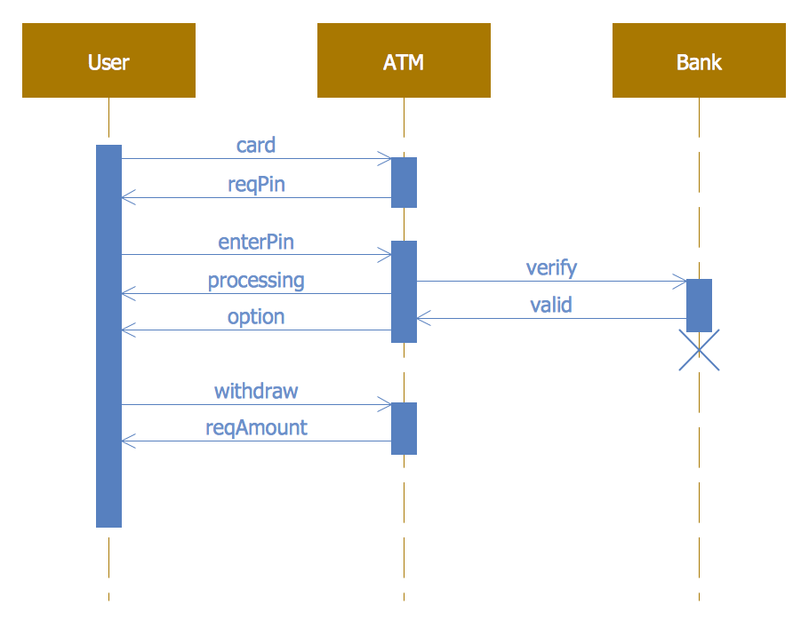

Example of a Sequential Structure:

Consider an algorithm that calculates the sum of two numbers and prints the result:

*1. Start*

*2. Input number1*

*3. Input number2*

*4. sum = number1 + number2*

*5. Output sum*

*6. End*

**3.2 Conditional Structure**

Very often when you write code, you want to perform different actions for

different conditions. You can use conditional statements in your algorithm/code to do this.

In Algorithm, we have the following conditional statements:

• **If statement -** executes some code if one condition is true

• **If...else statement** - executes some code if a condition is true

and another code if that condition is false

• **If...elseif... statement** - executes different codes for more than two

conditions

• **Switch statement** - selects one of many blocks of code to be executed

**a) If statement**

**Syntax**

***If*** *(condition)****then***

*Block of code*

***End if.***

**NB: If statement** is used to make a decision. The block of instructions following **If**, executes if the decision is true, and the block does not execute otherwise.

**Example 3:**

Write an algorithm which receives a number and informs the user when it is

positive.

**Answer:**

*Var a as integer Start*

*Write(“enter a number”)*

*Read(a)*

*If* ***(a>0)*** *then*

*Write(“the number is positive”)*

*End if*

*End*

To this question when the condition evaluates true it displays the instruction: **The number is positive** but when it evaluates for false **it displays nothing**

**b. If…. else statement**

The **if…else statement** is used to make a decision and gives the alternative when the condition evaluates to false. The block of instructions following the **if** executes if the decision is true, and the block after **else** when the condition evaluates to false.

Syntax

*If(condition) then*

*Block of code*

*Else*

*Block of code*

*End if*

*End*

**Example 1:**

Write an algorithm which receives a number and informs the user whether it is

positive or negative.

**Answer:**

*Start*

*Var a as integer*

*Write (“enter a number”)*

*Read(a)*

*If* ***(a>0)*** *then*

*Write (“the number is positive”)*

*else*

*Write (“the number is negative”)*

*End if*

*End*

To this question when the condition evaluates true it displays the message the number is positive when it evaluates to false it displays the message the number is negative.

**a. If …ElseIf….**

If statement may be used inside another if statement, in such case we call it a nested if.

**Example:**

Write an algorithm which receives student note and it displays the grade as follows:

Note form 16 and above: Grade A

|  |  |
| --- | --- |
| Note14-16  Note12-14  Note below 12  **Answer:** | Grade B:  Grade C:  Grade D |

*Start*

*Var Note as integer*

*Write(“Enter the Note”)*

*Read(Note)*

*If(Note>=16) then*

*Write(“Grade A”)*

*Elseif(Note>=14) then*

*Write(“GradeB”)*

*Else if (Note>=12)then*

*Write(“GradeC”)*

*Else*

*Write(“GradeD”)*

*End if*

*End*

**b. Multiple choice using ‘switch’**

A multiple-choice using **switch** helps to solve the problem caused by nested if statement in case there are many conditions to be tested. Switch receives a variable then it evaluates it using several **Case**.

**Syntax:**

Menu explaining to the user how to make a choice

*Switch(variable)*

***Case 1***

*Instructions*

***Case 2***

*Instructions*

*…….*

*……..*

***Case n***

*Instructions*

***Default***

*Instruction*

*End switch*

Example:

Write an algorithm which receives note and displays the student’s grade.

16 and above: Grade A

14-16: Grade B

12-14: Grade C

Less than 12: Grade D

**Answer:**

*Var Note as integer Start*

*Write(“Use number to chose the range of your note”)*

*Write(“enter 1 for note ranging from 16 and above”)*

*Write(“enter 2 for note ranging from 14 to16”)*

*Write(“enter 3 for note ranging from 12 to14”)*

*Write(“enter 4 for note less than 12”)*

*Write(“enter your choice now using number:”)*

*Read(Note)*

*Switch(Note)*

*Case1*

*Write(“You have grade A”)*

*Case2*

*Write(“You have grade B”)*

*Case3*

*Write(“You have grade C”)*

*Case4*

*Write(“You have grade D”)*

*Default*

*Write(“Your choice is not listed, try again”)*

*End switch*

*End*

**1.3 Iterative/Looping structure**

**What is a loop?**

A **loop** is a sequence of instructions that is continually repeated until a certain condition is reached.

A loop helps to repeat instruction or block of instructions. It assists in the algorithm where you want to carry out an activity for a certain number of times.

Often when you write code, you want the same block of code to run again in a row. Instead of adding several almost equal code-lines in a script, we can use loops to perform a task like this.

In Algorithm, we have the following looping statements:

* **while** - loops through a block of code if the specified condition is true
* **do...while** - loops through a block of code once, and then repeats the loop if the specified condition is true
* **for** - loops through a block of code a specified number of times
* **foreach** - loops through a block of code for each element in an array

**a. While loop**

The **While loop** executes its statements at least once even if the condition fails for the first time.

**Syntax**

*Variable=<start value>*

*Do while <variable><comparison operator><end value>*

*Instruction or block of instructions*

*Variable=variable+1*

*Loop*

**Example:**

Write an algorithm which use do while loop and displays numbers from 1 to 10 **Answer**:

Var A as integer

Start

*A=1*

*while A<=10*

*Write(A)*

*A=A+1*

*Loop*

*End*

**b. Do… while loop Syntax:**

*<Variable>=<start value>*

*do*

*Instruction or block of instructions*

*Variable=variable+1*

*while<variable><comparison operator><end value>*

Example:

Write an algorithm which use do while loop and displays numbers from 1 to 10

**Answer:**

*Start*

*Var A as integer*

*A=1*

*Do*

*Write(A)*

*A=A+1*

*while A>10*

*End*

**c. For loop**

The **for loop** is an iterative loop, it specifies some elements about the loop

in one single line.

**a.** Setting a loop counter to an initial value.

**b.** End which determines whether its value has reached the number of repetitions desired.

The value of the loop counter will be increased each time (iteration), and segment within the loop will be executed.

**Syntax:**

***for****(<initialize counter>****to*** *<end of repetitions desired>)* ***do***

*//bloc of instructions*

***End for***

Example:

Write an algorithm which ask a user to enter a number, and it displays the 10 next numbers. Solution:

*Start*

*Var A as integer*

*Write (“Enter a number”)*

*Read(A)*

*For (A=1 to 10) do*

*A=A+1*

*Write(A)*

*End for*

*End*

**d. Loops in Loops**

Loops in loops refer to what we call nested loops. These are loops that are such that when one increment by one the other continues inside the first.

*start*

*Var I, J As Integer*

*For I = 1 To 9 do*

*For J = 1 To I do*

*Write(J)*

*End for*

*End for*

*End*

**e. For Each Loop**

The foreach loop is used to iterate over a collection of items (like an array or a list) without needing to manage an explicit counter or index.

Here is an algorithm that calculates the sum of all numbers in a list using a foreach loop, presented in a generic pseudocode format:

**Algorithm: Calculate Sum of List**

**Objective:** To calculate the total sum of all elements within a given list of numbers.

* **Input:** A list of numbers, Numbers.
* **Output:** The Total_Sum.

**Steps:**

1. **Initialize** a variable Total_Sum to 0.
2. **For each** Number in the Numbers list:

**Add** the current Number to the Total_Sum.

1. **Return** the Total_Sum.

**Implementation Example using JavaScript (Foreach)**

*const numbers = [10, 20, 30, 40];*

*let totalSum = 0;*

*numbers.forEach((number) => {*

*totalSum += number;*

*});*

*console.log(totalSum); // Output: 100*

**1.5.4: Description of program flowchart**

● **Designing a Flowchart**

**1. Introduction to Flowchart**

**Flowchart** is diagrammatic /Graphical representation of sequence of steps to solve a problem.

**2. Advantages of flowchart:**

* Flowchart is an excellent way of communicating the logic of a program.
* Easy and efficient to analyse problem using flowchart.
* During program development cycle, the flowchart plays the role of a blueprint, which makes program development process easier.
* After successful development of a program, it needs continuous timely maintenance during its operation.
* The flowchart makes program or system maintenance easier.
* It is easy to convert the flowchart into any programming language code.
  1. **Description of Elements of Flowchart/ Flowchart Symbols**

Here is a chart for some of the common symbols used in drawing flowcharts

|  |  |  |
| --- | --- | --- |
| **Symbol** | **Symbol Name** | **Purpose** |
|  | Start/Stop | Used at the beginning and end of the algorithm to show start and end of the program. |
|  | Process | Indicates processes like mathematical operations. |
|  | Input/ Output | Used for denoting program inputs and outputs. |
|  | Decision | Stands for decision statements in a program, where answer is usually Yes or No. |
|  | Arrow | Shows relationships between different shapes. |
|  | On-page Connector | Connects two or more parts of a flowchart, which are on the same page. |

|  |  |  |
| --- | --- | --- |
|  | Off-page Connector | Connects two parts of a flowchart which are spread over different pages. |

* 1. **Guidelines for Developing Flowcharts**

These are some points to keep in mind while developing a flowchart -

• Flowchart can have only one start and one stop symbol

• On-page connectors are referenced using numbers

• Off-page connectors are referenced using alphabets

• General flow of processes is top to bottom or left to right

• Arrows should not cross each other

**Example Flowchart**

Here is the flowchart for going to the market to purchase a pen.

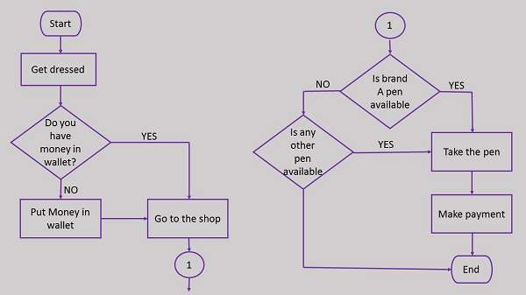

Here is a flowchart to calculate the average of two numbers

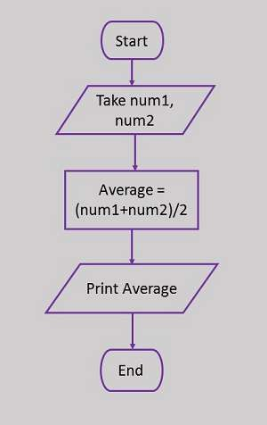

1. **Selection/conditional structures flowchart**

Conditional statements help you to decide based on certain conditions. Very often when you write code, you want to perform different actions for different decisions. You can use conditional statements in your code to do this. In all programming languages we have the following conditional statements:

* 1. If statement or simple IF statement
  2. If/else statement
  3. Nested if statement
  4. If/Else If statement
  5. Switch statement (will be seen later)

**Simple IF statement**

Use IF to specify a block of code (statements) to be executed or a decision made,

Syntax Start

If (condition) then

Instructions

End if

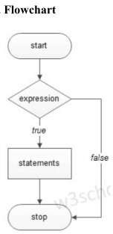End

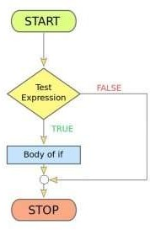

* 1. **IF/ELSE statement**

Use if/else to specify a block of code to be executed, if the same condition is false Syntax

Start

If (condition) then

Instructions

Else Instructions

End if

End

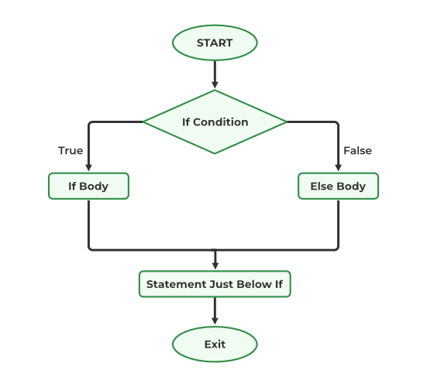

* 1. **ELSE/ IF statement**

Use else/if to specify a new condition to test, if the first condition is false.

Syntax

Start

If (condition) then

Instructions

Else if (condition) then

Instructions

Else if (condition) then

Instructions

…

Else [optional]

Instructions

End if

End

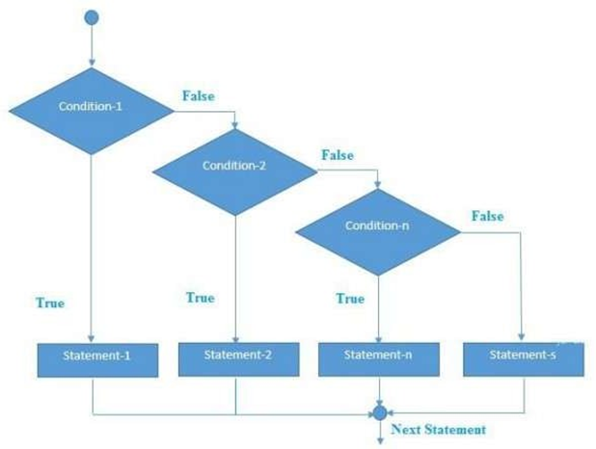

**3. NESTED IF statement**

A NESTED IF is an IF statement that is the target of another if statement. Nested if statements mean an IF statement inside another IF statement.

**Syntax Start**

If (condition)

If (condition) then

Instructions

…

Else Instructions

End if

Else [optional]

Instructions

End if

End

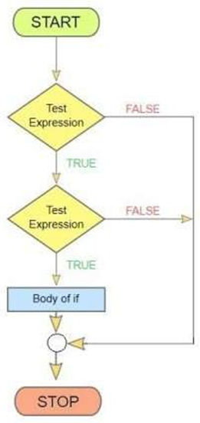

Arrange the steps in a logical order, typically from top to bottom or left to right. Ensure that the flow of the process is easy to follow and that decision points are clearly indicated.

1. **Use Connectors:**

For complex flowcharts, use connectors (small circles or labeled arrows) to indicate continuation points, especially when the flowchart spans multiple pages.

1. **Label Decision Paths:**

Clearly label the paths branching from decision points to indicate the conditions or outcomes leading to each path.

1. **Provide a Key or Legend:**

If your flowchart uses specialized symbols or colors, include a key or legend to explain their meanings.

**1.5.5: Draw a basic flow chart in draw.io**

* **Draw a basic flow chart in draw.io**

You can create many different types of diagrams with draw.io and our online diagram editor. To learn how to use the editor, let’s start with a basic flowchart to document a process.

* **Steps to draw a basic flow chart in draw.io:**

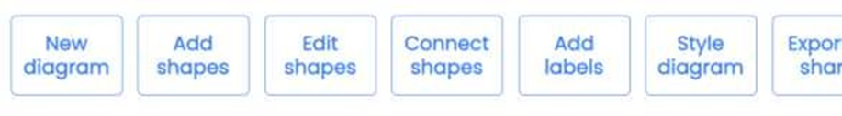

1. Create a new blank diagram
2. Add shapes to the drawing canvas
3. Move, resize, rotate, and delete shapes
4. Connect shapes
   * Draw a floating connector
   * Draw a fixed connector
   * Change the path of a connector
5. Add labels
6. Style your flow chart
7. Export and share your flow chart Details:

**Step Step 1: Create a new blank diagram**

1. Go to [the online draw.io editor](https://app.diagrams.net/).
2. Select *Device* to save your flow chart to your device. **Note:** You can [select another location to store your diagram file](https://www.drawio.com/doc/faq/storage-location-select), but you may be prompted to grant the editor permission if you select a cloud storage platform.



1. Click on the Create New Diagram

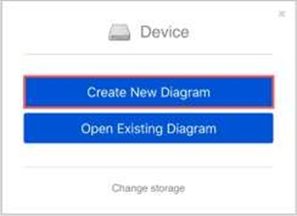

1. In the template manager, enter a filename for your flow chart, ensuring Blank Diagram is selected, then click Create.



**Step 2: Add shapes to the drawing canvas**

There are a number of different ways to add shapes to the drawing canvas in draw.io. **Add the first step** - Use one of the following methods to add a rectangle to the drawing canvas. Rectangles represent the steps in your process.

* + Click on a rectangle in the *General* shape library to add it the drawing canvas.
  + Double-click on an empty area on the drawing canvas and select a rectangle shape.
  + Drag a rectangle from the *General* shape library to a specific position on the drawing canvas.

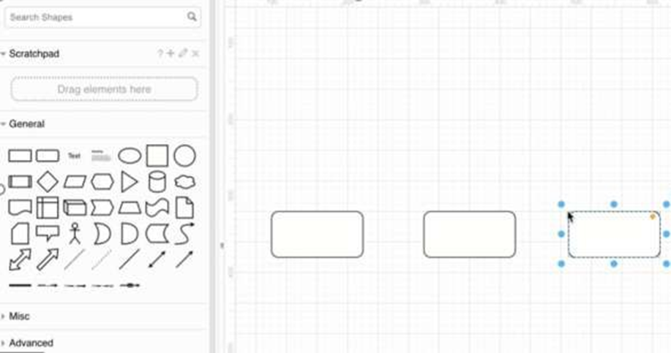

**Add more shapes** - Use one of the following methods to add extra shapes to represent the next steps in your process.

Hover over the first shape you placed to see the four direction arrows. Click on one of the shapes, then select a shape to add and connect it in that direction.



Drag a shape from the shape library and hover over an existing shape until you can see the four direction arrows. Move over one of these direction arrows, and drop the shape you have dragged. It will be added to the drawing canvas and connected in that direction.

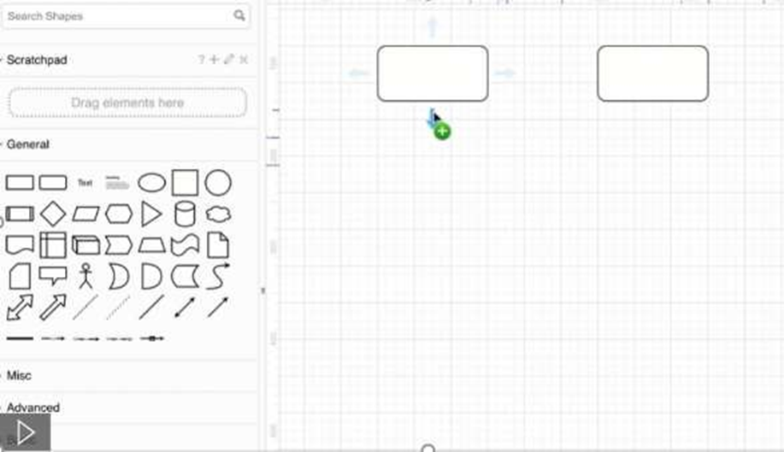

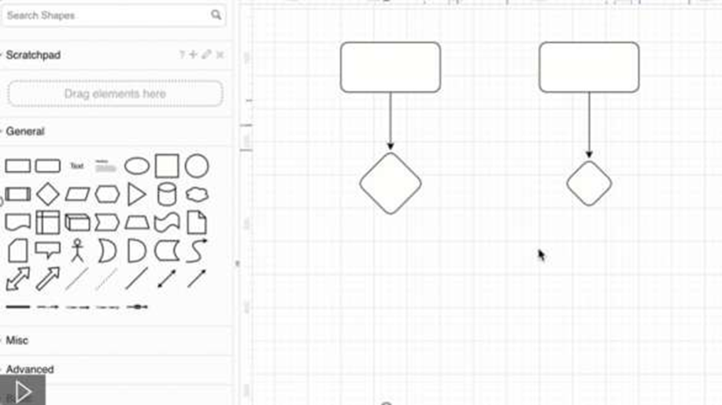

Notes: If you added multiple shapes by simply clicking on them in the shape library, you can connect them later.

In addition to the shapes in the *General* and *Advanced* shape libraries, you can use shapes from the *Flowchart* shape library.

1. Click on *More Shapes* at the bottom of the left panel.
2. Click on the checkbox next to the *Flowchart* shape library’s name to enable it.



1. Click *Apply*. The *Flowchart-shaped* library is now available in the left panel.

**Step 3: Move, resize, rotate, and delete shapes**

To select a shape, click on it. To select multiple shapes, hold down Shift or Cmd and click on them.

**Move** - Select and drag a shape that is on the drawing canvas to another position.

**Resize** - Select a shape. Drag any of the round ‘grab’ handles to make the shape smaller or larger. Hold down Control when you resize shapes to keep them centred. See how to resize groups of shapes

**Rotate** - Select a shape. Drag the rotate grab handle (the round arrow) at the top right corner of the shape to rotate the shape around its center point.

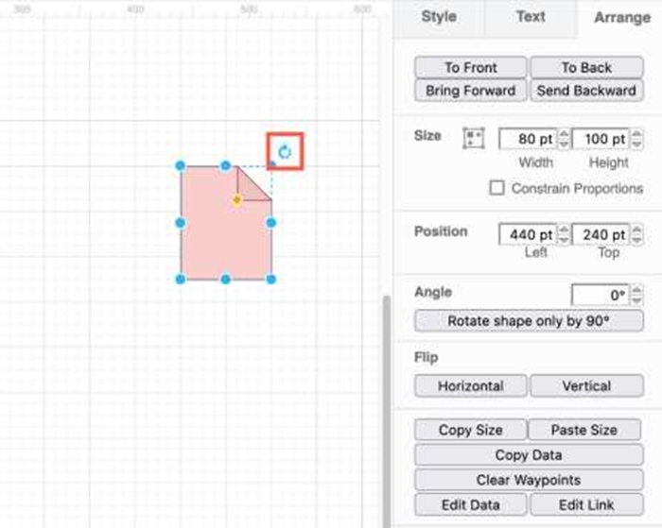

**Delete** - Select a shape, then press Backspace or Delete, or click on the *Delete* tool in the toolbar.

**Step 4: Connect shapes**

Connectors are lines that [connect your shapes together](https://www.drawio.com/blog/connect-shapes.html) and may or may not have arrows at one or both ends.

**Step 5: Add labels**

Short labels on shapes make it easier to understand a diagram quickly.

1. Double click on a shape. Start typing to replace the label with your own text. Alternatively, single click on a shape and start typing to add or edit the label.
2. Press *Enter* to save the label text.

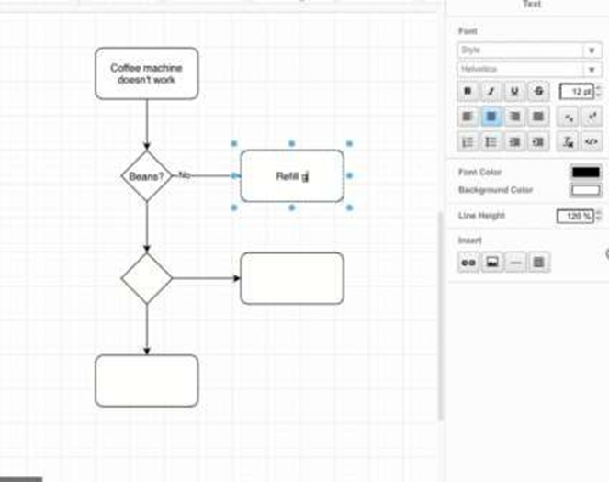

**Connector labels**

You can add more than one label to a connector - at the source end, the target end, and in the middle.

* + Double click in the position you want to add a text label there.
  + To reposition the connector label text, click on the label, then drag the small yellow diamond to a new position.

If you reroute the connector, you may need to update any labels you had manually positioned, but usually the label will move intelligently with the connector.

**Step 6: Style your flow chart**

Once you have finished adding all the shapes, connectors and labels, you can style your flow chart.

1. Select a shape, or hold Shift down and click on multiple shapes and connectors to select many.

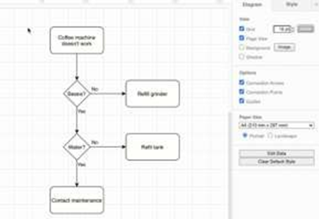

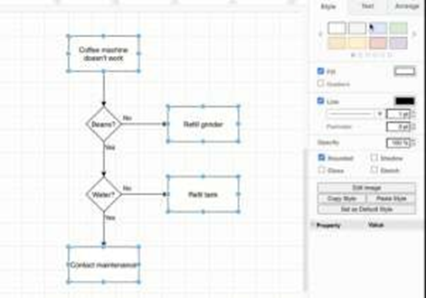

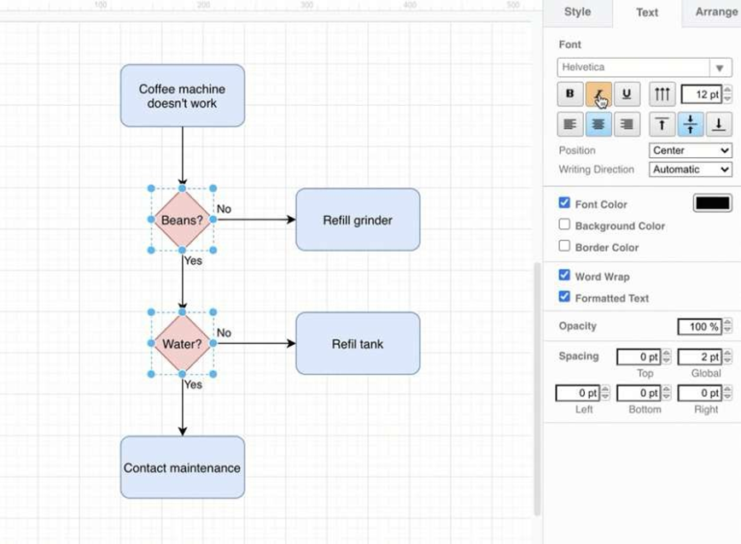

Add colours and [style your shapes](https://www.drawio.com/doc/faq/shape-styles.html) and [connectors](https://www.drawio.com/doc/faq/connector-styles.html) via the *Style* tab.

* + The style palette at the top of the *Style* tab changes both the fill and outline colour. Click the left or right arrows to view more styles.

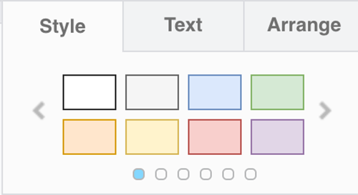

* To set your own colour, click on the colour button next to *Fill* or *Line*, select a a new colour or enter a hex colour code.



* Style a selected connector to have [arrows on both ends](https://www.drawio.com/doc/faq/connector-bidirectional.html) or [no arrows](https://www.drawio.com/doc/faq/connector-no-arrows.html).

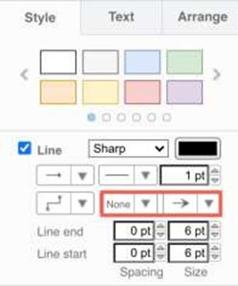

* [Change the text style](https://www.drawio.com/doc/faq/text-styles.html) of labels on the *Text* tab.
  + Select a different *Font* from the list.
  + Add *Bold*, *Italics*, or *Underline*.
  + Change the justification to be left, right or centred.
  + Click on the colour button next to *Font Color*.



**Step 7: Export and share your flow chart**

You can share your diagram in a number of different ways via the *File > Export as* menu. The most common export formats are as images or as a URL.

* Export as a *PNG*, *JPEG* or *SVG* to convert your diagram to an image that you can paste into a website or email.

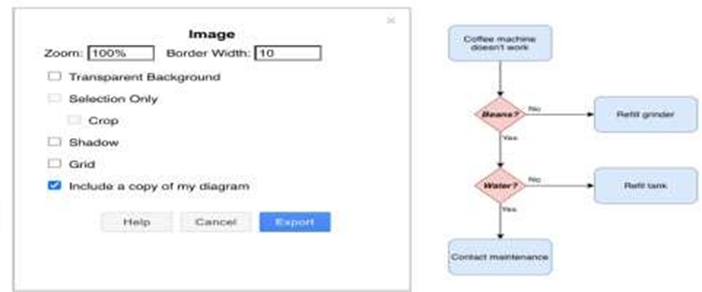

* [Export as a *URL*](https://www.drawio.com/blog/export-url.html)to encode your entire diagram in a URL. When you share this (very long) URL, the person viewing the diagram will see a copy - they don’t open or edit your original diagram.





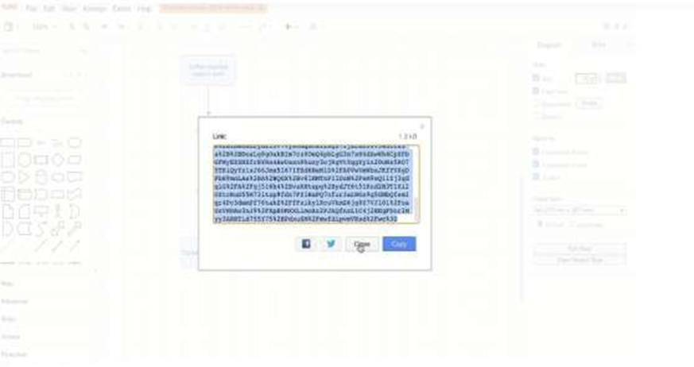



**Points to Remember**

* Steps to draw a basic flow chart in draw.io:
  1. Create a new blank diagram
  2. Add shapes to the drawing canvas
  3. Move, resize, rotate, and delete shapes
  4. Connect shapes
  5. Draw a floating connector
  6. Draw a fixed connector
  7. Change the path of a connector
  8. Add labels
  9. Style your flow chart

**Learning Outcome 2: Apply Data Structure**

**Indicative content 2.1: Identification of Data Structure Concepts**

**2.1.1: Description of data structure concepts**

**Data Structure Concepts**

**1. DATA STRUCTURE**

Data Structure is a way to store and organize data so that it can be used efficiently. It is a way of arranging data on a computer so that it can be accessed and updated efficiently.

Every application, piece of software, or programs foundation consists of two components: **algorithms** and **data**. Data is information, and algorithms are rules and instructions that turn the data into something useful to programming. Put another way, remember these two simple equations:

Related data + Permissible operations on the data = Data Structures

Data structures + Algorithms = Programs

Every program relies on data and algorithms. Algorithms are sets of instructions that dictate how data is processed to produce meaningful results. Data, on the other hand, represents the information that algorithms operate on. Together, they form the foundation on which all software systems are built. Data structures play a crucial role in the interaction between algorithms and data.

**The data structures have the following importance for programming:**

* Data structures study how data are stored in a computer so that operations can be implemented efficiently
* Data structures are especially important when there is a large amount of information to deal with.
* Data structures are conceptual and concrete ways to organize data for efficient storage and manipulation

**2. CHARACTERISTICS OF DATA STRUCTURES**

Data Structure is the systematic way used to organize the data. The characteristics of Data Structures are:

✓ **Linear or Non-Linear**

This characteristic arranges the data in sequential order, such as arrays, graphs etc.

✓ **Static and Dynamic**

Static data structures have fixed formats and sizes along with memory locations. The static characteristic shows the compilation of the data.

✓ **Time Complexity**

The time factor should be very punctual. The running time or the execution time of a program should be limited. The running time should be as less as possible. The less the running time, the more accurate the device is.

✓ **Correctness**

Each data must definitely have an interface. Interface depicts the set of data structures. Data Structure should be implemented accurately in the interface.

✓ **Space Complexity**

The Space in the device should be managed carefully. The memory usage should be used properly. The space should be less occupied, which indicates the proper function of the device.

**3. TYPES OF DATA STRUCTURES**

There are two types of data structures:

* Primitive data structure
* Non-primitive data structure

Check out the graph below to better understand how data structure types are categorized.

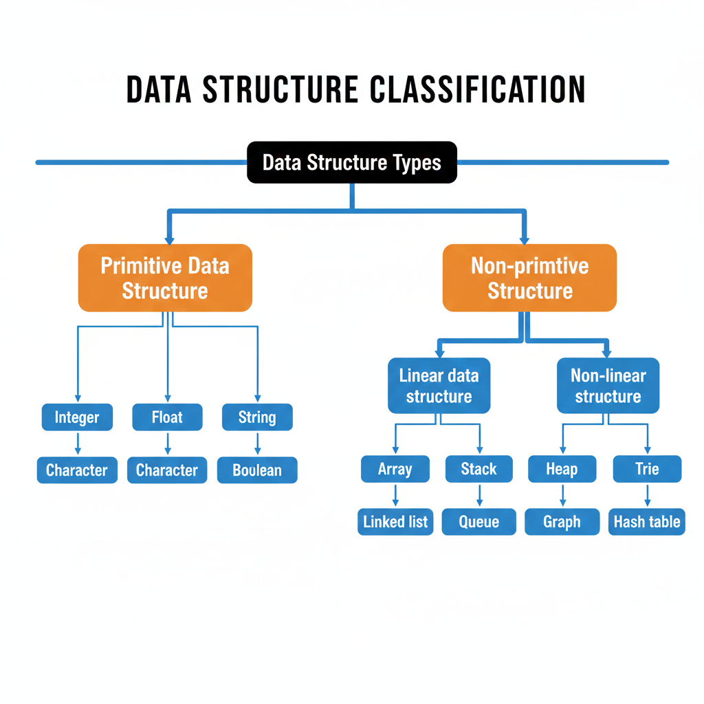

Tree

**3.1. Primitive Data Structures**

These are the most basic building blocks. They hold a **single value** and are predefined by the programming language.

* **Integer:** Whole numbers (e.g., 5, -10).
* **Float:** Numbers with decimals (e.g., 3.14).
* **Character:** Single letters or symbols (e.g., 'A', '$').
* **String:** A sequence of characters (e.g., "Hello"). *Note: In some languages, strings are considered non-primitive, but this chart lists them here.*
* **Boolean:** Logic values (True or False).

**3.2. Non-Primitive Data Structures**

These are more complex structures that **group multiple values** together.

Non-primitive data structures are created with primitive data structures as their building blocks to efficiently organize and manage a collection of data. They can handle different data types and complex operations like searching, sorting, insertion, deletion, and more.

They are divided into two main types:

**A. Linear Data Structures**

Data elements are arranged in a **sequential order**, where each element is connected to its previous and next element.

* **Array:** A collection of elements stored at contiguous memory locations.
* **Stack:** Follows "Last-In-First-Out" (LIFO)—like a stack of plates.
* **Queue:** Follows "First-In-First-Out" (FIFO)—like a line at a store.
* **Linked List:** Elements (nodes) where each node points to the next one.

**B. Non-Linear Data Structures**

Data is attached in a **hierarchical or interconnected** way, rather than a straight line.

* **Tree:** A hierarchical structure (like a family tree or folder system).
* **Heap:** A specialized tree-based structure used for sorting and priority.
* **Trie:** A tree-like structure often used for searching words or prefixes.
* **Graph:** A network of nodes connected by edges (like a social network or maps).
* **Hash Table:** Stores data in "key-value" pairs for very fast lookups.

**4. CLASSIFICATIONS OF DATA STRUCTURES**

As mentioned above data structures are divided into two categories:

1. Linear data structure

2. Non-linear data structure

Check out the graph below to better understand how data structure types are categorized.

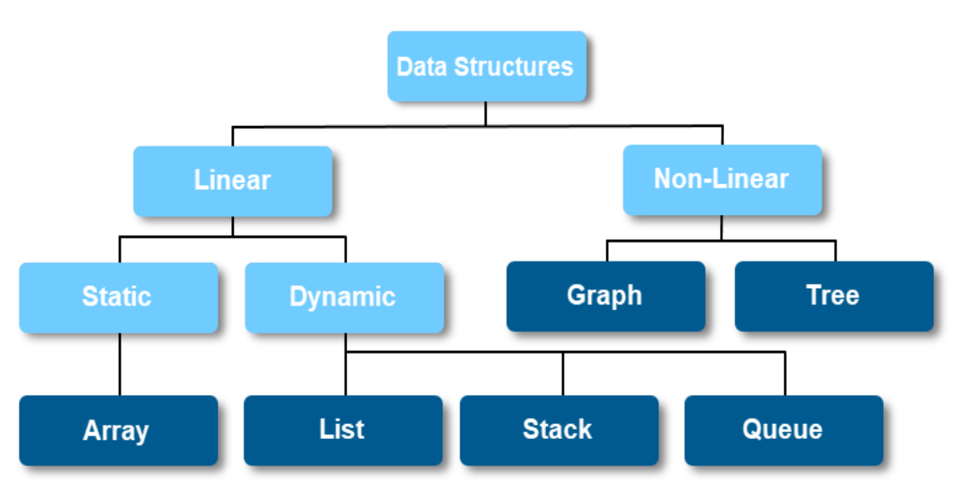

**4.1 Linear Data Structures**

In linear data structure, data elements are linked to one another in a sequential arrangement. In this manner, a single run can traverse the structure. Linear data structures consist of four types. They are:

• Stack

• Array

• Queue

• Linked list

Linear Data structures can also be classified as:

✓ **Static data structure**

Static data structure has a fixed memory size. It is easier to access the elements in a static data structure.

An example of this data structure is **an array**.

✓ **Dynamic data structure**

In the dynamic data structure, the size is not fixed. It can be randomly updated during the runtime which may be considered efficient concerning the memory (space) complexity of the code.

**4.2 Non-Linear Data Structures**

In linear data structure data elements are randomly arranged. The elements are non-arranged sequentially.

In Non-linear data structures, there are different paths for an element to reach the other element.

The data elements in the non-linear data structures are connected to one or more elements.

There are two types of non-linear data structures. They are:

• Tree Data Structure

• Graph Data Structure

• Table Data Structure

Let's learn about each type in detail.

**Popular linear data structures are:**

**1. Array Data Structure**

In an array, elements in memory are arranged in continuous memory. All the elements of an array are of the same type. And, the type of elements that can be stored in the form of arrays is determined by the programming language.

In an array, each element is associated with an index, a numerical identifier that indicates the element's position. Indexing begins at 0 for the first element and increments sequentially up to the array size minus one. For example, in an array of size 5, the indices range from 0 to 4, like in the picture below.

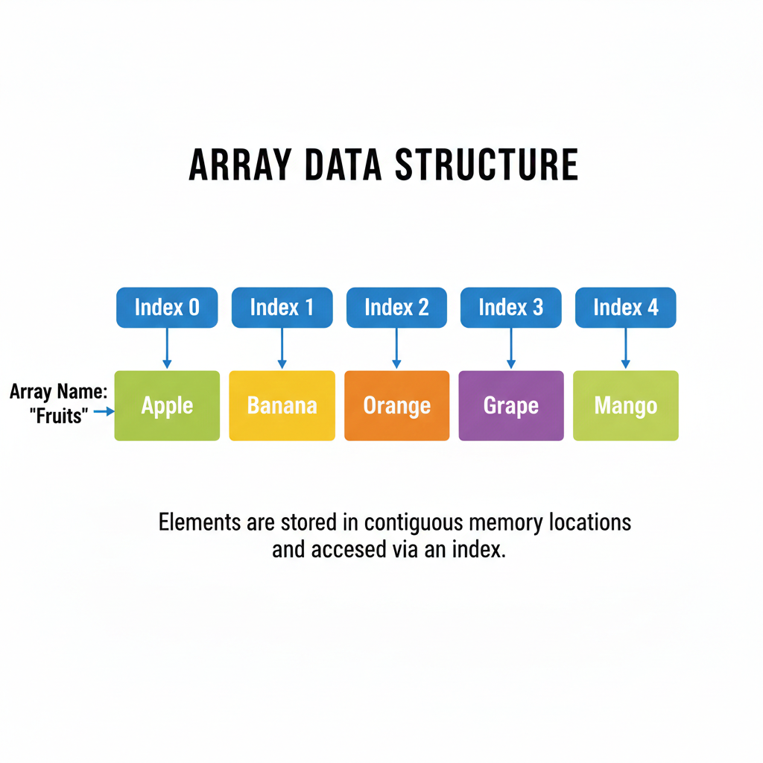

**2. Stack Data Structure**

In stack data structure, elements are stored in the LIFO principle. That is, the last element stored in a stack will be removed first.

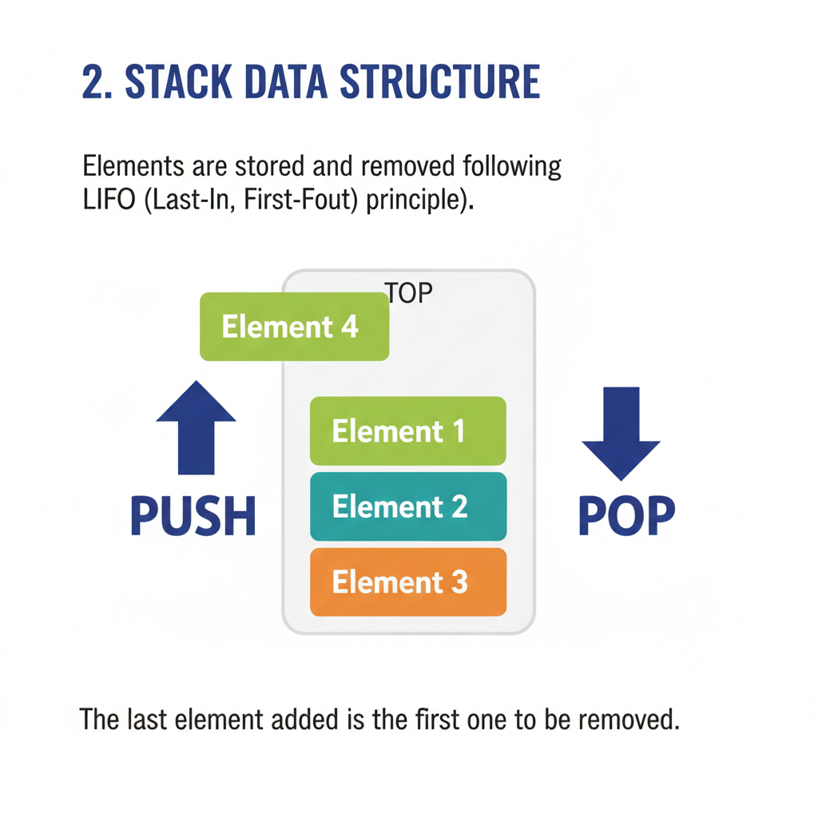

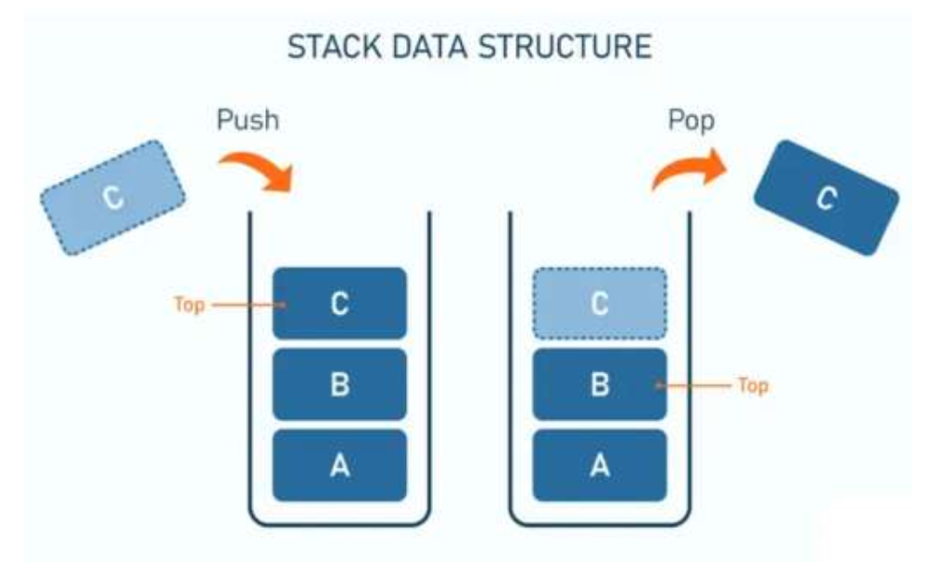

**3. Queue Data Structure**

Unlike stack, the queue data structure works in the FIFO principle where first element stored in the queue will be removed first.

It works just like a queue of people in the ticket counter where first person on the queue will get the ticket first.

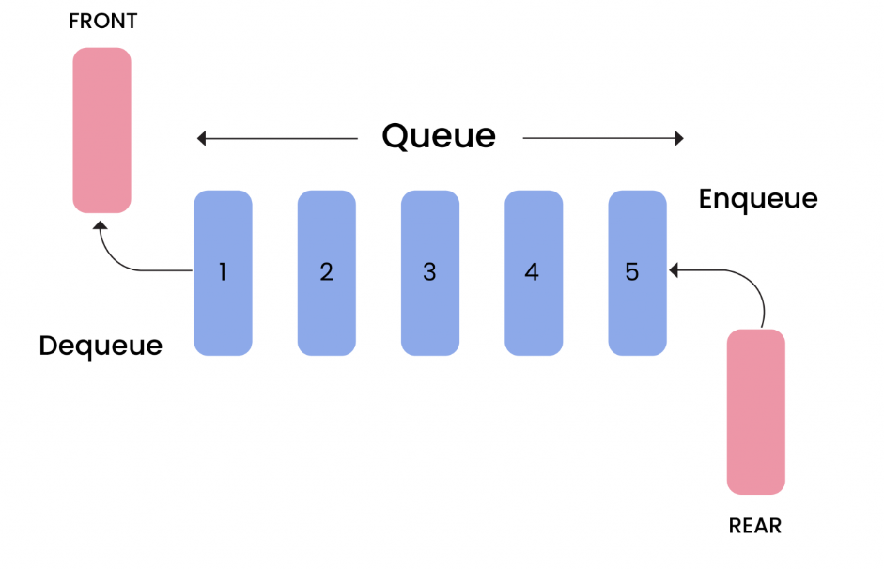

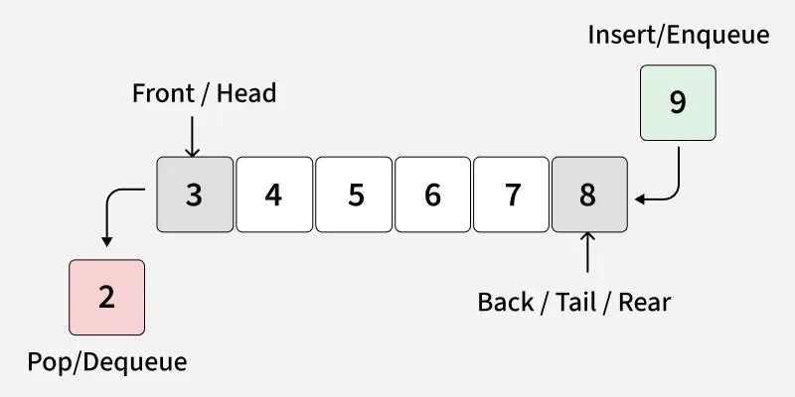

**Basic Operations of a Queue**

We can perform the following operations on a queue-

* **Enqueue ()** – This is the process of adding or storing an element to the rear end(back-end) of a queue.
* **Dequeue ()** – It refers to removing or accessing an element from the front-end of a queue.
* **Peek ()** – This function brings the asked element to the front-end of the queue without removing it.
* **isEmpty (**) – It checks if the queue is empty.
* **isFull ()** – It checks if the queue is full.
* **Front:**Position of the entry in a queue ready to be served, that is, the first entry that will be removed from the queue, is called the front of the queue. It is also referred as the head of the queue.
* **Rear:** Position of the last entry in the queue, that is, the one most recently added, is called the rear of the queue. It is also referred as the tail of the queue.
* **Size:** Size refers to the current number of elements in the queue.
* **Capacity:** Capacity refers to the maximum number of elements the queue can hold.

**4. Linked List Data Structure**

In linked list data structure, data elements are connected through a series of nodes.

And each node contains the data items and address to the next node.

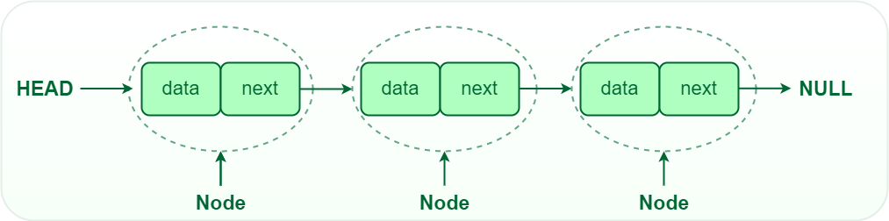

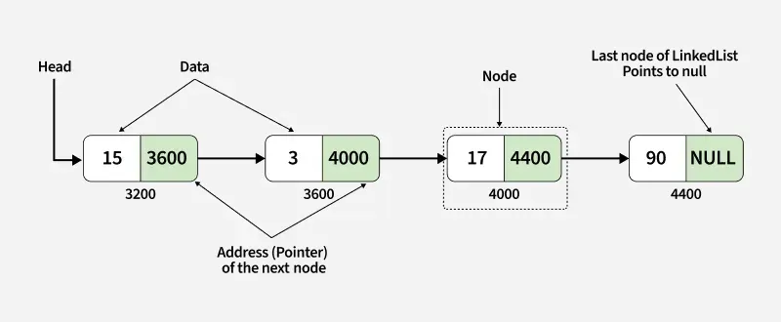

**Link to:** [**Linked List - Types, Applications, Operations**](https://www.masaischool.com/blog/linked-list/)

**Popular Non-linear data structures are:**

**1. Graph Data Structure**

In graph data structure, each node is called vertex and each vertex is connected to other vertices through edges.

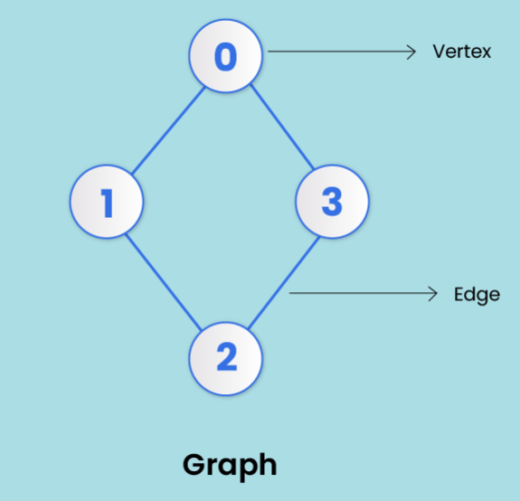

**V (Vertices) = {0, 1, 2, 3}**

**E (Edges) = {(0,1), (0,2), (0,3), (1,2)}**

**G (Graph) = {V, E}**

**Graph terminology**

**Vertex**- Each node of a graph is called a vertex. (plural - vertices). In the image above, the dots represented by 0, 1, 2, and 3 are vertices.

**Edge** - Edges in a graph are the lines that connect two vertices. In the image above- the line (0, 1) from 0 to 1 represents an edge, similarly (1, 2), and so on.

Edges can be represented in the form of two-dimensional arrays.

**Adjacency -** A vertex is adjacent to another vertex if there is an edge connecting them. In the image above, vertices 0 and 1 are adjacent, but vertices 1 and 3 are not adjacent as there’s no edge between them.

**Paths -**A series of edges that takes you from one vertex to another when they’re not adjacent to each other. In the above example: 1 and 3 are not adjacent. So, the sequence of edges [(1, 2), (2, 3)] will represent a path.

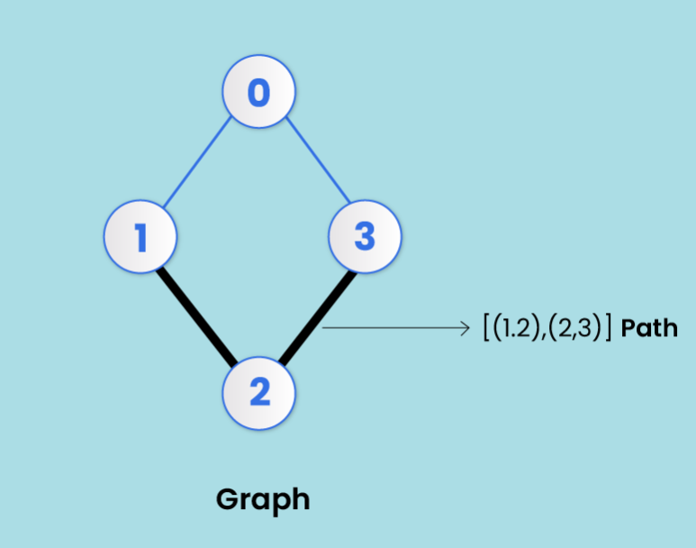

**Directed Graph** - A graph in which an edge (0, 1) doesn't necessarily mean that there is an edge (1, 0) as well. An edge in a directed graph travels in only one direction. Arrows are used to represent that direction.

(More on directed graphs visit): [Graph Data Structure - Explained With Examples](https://www.masaischool.com/blog/graph-data-structure-explained-with-examples/)

**2. Trees Data Structure**

A tree is a collection of elements (nodes) connected with edges that reflect parent-child relationships. Each node (except the root the topmost node) has a single parent. Nodes without children are known as leaves. You’ve seen this structure when looking at a family tree or organizational chart.

Like a graph, a tree is also a collection of vertices and edges. However, in tree data structure, there can only be one edge between two vertices.

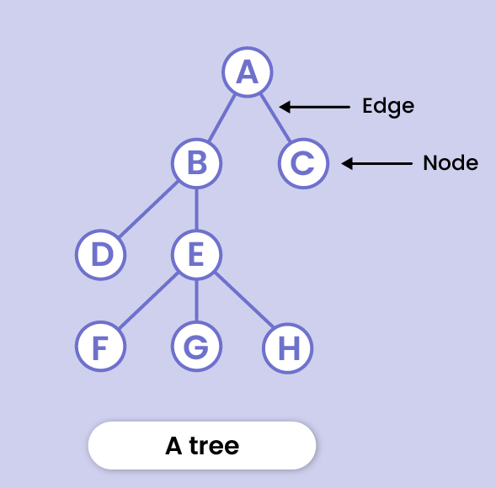

Following are the key points of a tree data structure:

* Trees are specialized to represent a hierarchy of data
* Trees can contain any type of data be it strings or numbers

Here’s the logical representation of a tree:

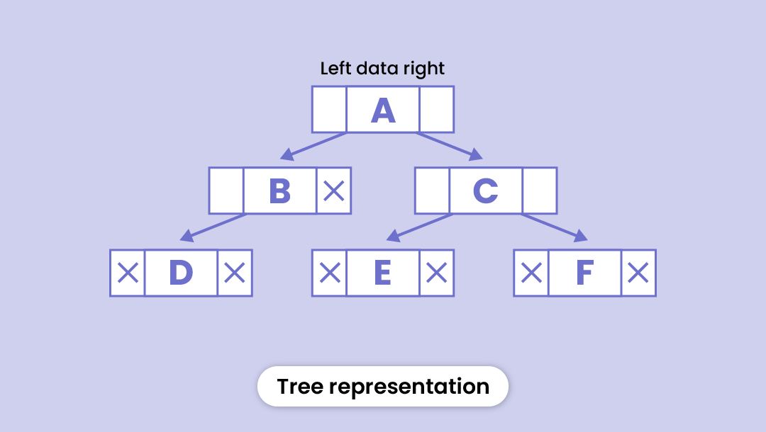

**Basic terms of a tree data structure**

**Root node**

The topmost node in the tree hierarchy is known as the root node. In other words, it's the origin point of the tree that doesn't have any parent node.

**Child node**

The descendant of any node is said to be a child node.

**Parent node**

If the node has a descendant i.e. a sub-node, it's called the parent of that sub-node.

**Siblings**

Just like a family tree, nodes having the same parent node are called siblings.

**Leaf node**

It's the bottom-most node in the tree that doesn't have any child node. They are also called external nodes. The "end" of a tree branch is normally where the leaf nodes are located.

**Internal node**

A node having at least one child node is known as an internal node. Internal nodes in a tree structure are often located "between" other nodes.

**Ancestor Node**

Any node that lies between the root and the current node is an ancestor node. You may think of ancestor nodes as "parents, grandparents, etc."

**Descendant**

A descendant is any child, grandchild, great-grandchild, etc. of the current node. Any node in the tree structure that is "below" the current node is referred to as a descendent.

**Edges**

The link between any two nodes is called an edge.

**Height**

The height of a node is the number of edges from that node to the leaf node (the lowermost node in the hierarchy)

In the figure below - the height of node B will be the number of edges from B to the external node i.e. D. Thus h = 1)

**Depth**

The depth of a node is the number of edges it takes from the root node to that node.

In the figure below - the depth of node D will be the number of edges from A to D. Thus d = 2)

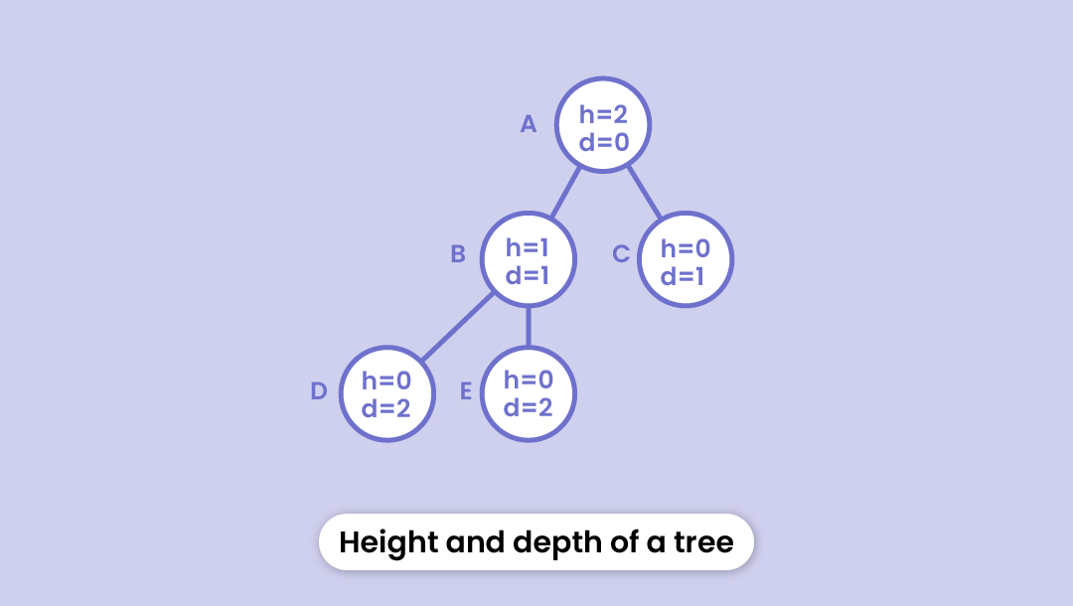

**Degree**

The total number of branches coming out of a node is considered to be the degree of that node.

**Forest**

It's not hard to guess, is it? A collection of disconnected trees is called a forest. If you cut the root of a tree, the disjoint trees hence formed make up a forest. (As shown in the figure)

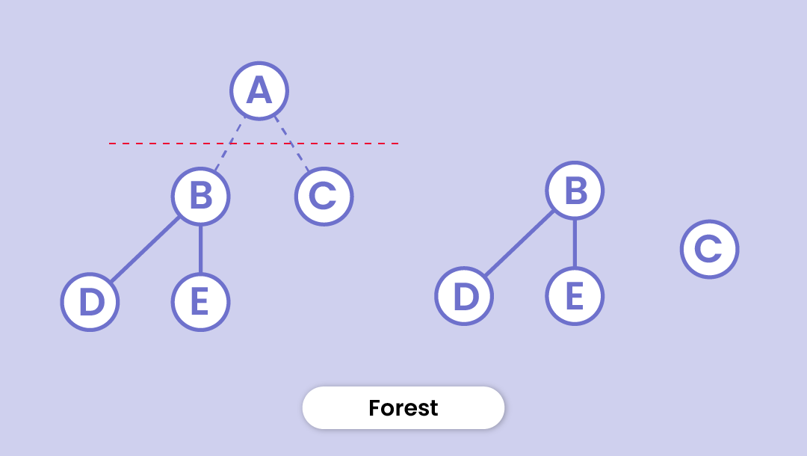

**3. Hash table data structure**

A hash table or hash map stores key-value pairs in an array. The key is a unique identifier to access or retrieve the value, which is the associated data or information.

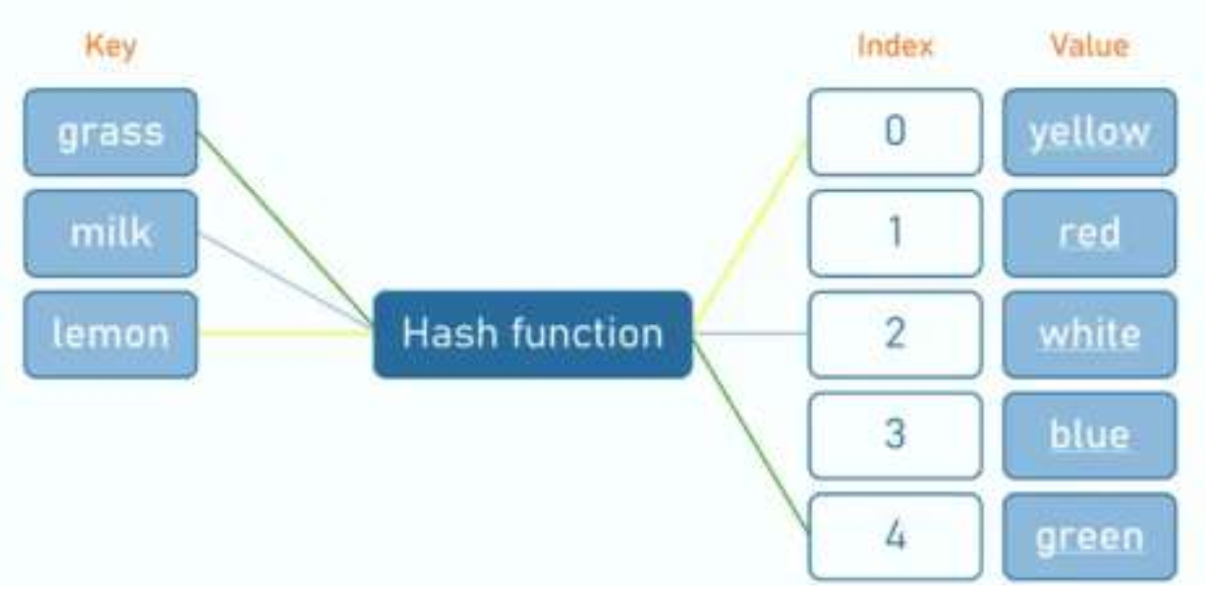

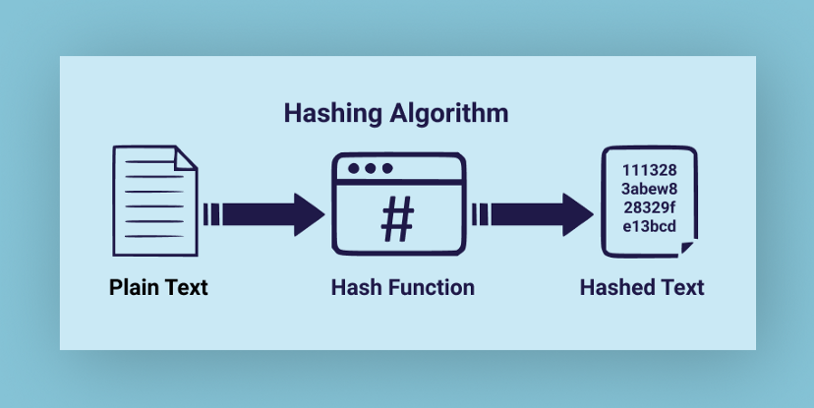

The hash function takes a key as input and produces a unique numerical value called a hash code that serves as an index for a particular data element.

This mapping process is deterministic, meaning the same key will always be hashed to the same index, facilitating rapid lookup and retrieval of values.

We use hash tables to quickly map keys to specific locations in the array.

The goal of the hash function is to distribute keys appropriately across the array indices, minimizing collisions (situations where multiple keys map to the same index).

Hash tables are common in scenarios where efficient storage and retrieval of key value pairs are required for example, caching systems.

**Applications of HashMaps**

**1. Database Indexing**: HashMaps can significantly speed up data retrieval, which is crucial in database operations. They are used to index large amounts of data. A unique key is assigned to each data record. This key is then hashed, and the data is stored at the resulting hash code's index.

**2. Caching**: They are used in caching data, which also boosts performance. For instance, when a function is called with the same value multiple times, the result can be stored in a hashmap after the first call. Subsequent calls can then retrieve the stored value from the cache instead of executing the entire function again.

**3. Routers and DNS Resolution**: Routers use hash tables to route internet traffic efficiently. Similarly, Domain Name System (DNS) resolvers use hashmaps to quickly find an IP address given a domain name.

**4. Language Interpretation**: HashMaps are used in compilers and interpreters for language translation. The variables and functions in a program are stored in a symbol table implemented as a hashmap. The compiler or interpreter can then quickly look up variables and functions as it processes the code.

Follow this link for more: [Understanding HashMap Data Structure With Examples](https://www.masaischool.com/blog/understanding-hashmap-data-structure-with-examples/)

**5. MAJOR DATA STRUCTURE OPERATIONS**

The major or the common operations that can be performed on the data structures are:

• **Searching:** We can search for any element in a data structure.

• **Sorting:** We can sort the elements of a data structure either in an ascending or descending order.

• **Insertion:** We can also insert the new element in a data structure.

• **Update:** We can also update the element, i.e., we can replace the element with another element.

• **Deletion:** We can also perform the delete operation to remove the element from the data structure.

**6. LIST REPRESENTATION**

2.1 **List representation:** List presentation in data structures refers to how lists are organized and represented in a programming environment. There are several ways to implement lists, each with its advantages and use cases:

✓ **Arrays:** An array is a collection of elements identified by index or key. In a one-dimensional array, elements are stored sequentially in memory.

✓ **Linked Lists:** A linked list is a linear collection of elements called nodes.

Each node contains data and a reference (or pointer) to the next node in the sequence.

**Types of Linked list.**

✓ **Singly Linked List**: Each node points to the next node.

✓ **Doubly Linked List:** Each node points to both the next and the previous node.

✓ **Circular Linked List:** The last node points back to the first node, creating a circular structure.

2.2 **List operations**

**List operations** refer to the various actions that can be performed on lists, whether they are implemented as arrays, linked lists, or other data structures. Here we have

common list **operations and their typical implementations:** •**Insertion operation:**

Refers to add a new element to the list.

✓ **Types Insertion operation in list**

**At the End:** Adding an element to the end of the list (often referred to as appending).

**At a Specific Position:** Adding an element at a specific index or location in the list.

✓ **Implementation in list**

**Arrays:** Inserting at the end is usually straightforward, but inserting at a specific position requires shifting elements**.**

**Linked Lists**: Inserting is generally efficient as it involves updating pointers.

For singly linked lists, the insertion might require traversal to find the correct position.

**Deletion operation:**

Refers to removing an element from the list.

✓ **Types in list**

**By Value:** Removing the first occurrence of a specific value**.**

**By Index:** Removing the element at a specific index or position.

✓ **Implementation in list**

**Arrays:** Removing an element requires shifting elements to fill the gap.

**Linked Lists:** Deleting involves updating pointers. In a doubly linked list, deletion is efficient as both previous and next pointers are available.

**Traversal Operation**

Refers to visit each element of the list to perform some operation.

✓ **Implementation in list**

**Arrays:** Simple iteration through indices.

**Linked Lists:** Requires starting from the head and following pointers to visit each node.

**Sorting:** Arranging the elements of the list in a specific order (e.g., ascending or descending).

**Update:** refers to modify the value of an element at a specific index or position.

**7. STRUCTURES**

**Structures (also called structs)** are a way to group several related variables into one place. Each variable in the structure is known as a member of the structure.

Unlike an array, a structure can contain many different data types (int, float, char, etc.).

**7.1Characteristics of Structures in Programming**

•**Composite Data Type**: Structures allow you to create complex data types by combining simpler data types, such as integers, floats, and strings.

•**Member Variables**: Each structure can contain multiple member variables. These can be of different types and are accessed using a dot notation.

•**Encapsulation**: Structures encapsulate related data, making it easier to manage and pass around as a single unit. This is especially useful for grouping related data fields together.

•**Data Alignment**: In some languages, structures may have specific alignment requirements or padding to ensure efficient access. This can affect the size of the structure.

•**User-defined**: Structures are user-defined types, meaning that programmers can create them according to their needs.

**2.1.2: Description of data structure algorithm**

An algorithm in the context of data structures (DS) is a step-by-step procedure or formula for solving a problem or performing a task. Algorithms manipulate data structures, which are organized formats for storing and managing data

**1. Searching techniques**

Searching in data structure refers to the process of finding the required information from a collection of items stored as elements in the computer memory.

These sets of items are in different forms, such as an array, linked list, graph, or tree.

Another way to define searching in the data structures is by locating the desired element of specific characteristics in a collection of items.

Different Searching Methods Searching in the data structure can be done by applying searching algorithms to check for or extract an element from any form of stored data structure.

These algorithms are classified according to the type of search operation they perform, such as:

● **Sequential search**

The list or array of elements is traversed sequentially while checking every component of the set. For example – **Linear Search.**

● **Interval Search**

The interval search includes algorithms that are explicitly designed for searching in sorted data structures. In terms of efficiency, these algorithms are far better than linear search algorithms. **Example- Logarithmic Search, Binary search.**

**2. Classification of Sorting Algorithms**

Sorting is an algorithm that arranges the elements of a given list in a particular order [ascending or descending].

● Sorting algorithms are categorized on the following basis

✓ **By number of comparisons:** Comparison-based sorting algorithms check the elements of the list by key comparison operation and need at least O(n log n) comparisons for most inputs. In this method, algorithms are classified based on the number of comparisons. For comparison-based sorting algorithms, best case behavior is O(n log n) and worst-case behavior is O(n2). For example – Quick Sort, Bubble Sort, Insertion Sort etc.

✓ **By Number of Swaps:** In this method, sorting algorithms are categorized

by the number of swaps (interchanging of position of two numbers, also called inversion).

✓ **By Memory Usage:** Some sorting algorithms are “in place” and they need

O(1) or O(log n) memory to create auxiliary locations for sorting the data temporarily**.**